Joseph Junius Ory
August 17, 1917 – April 13, 1989

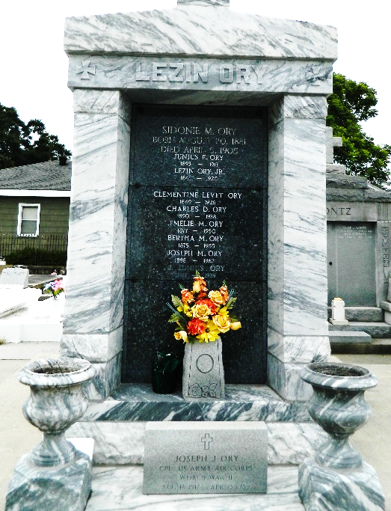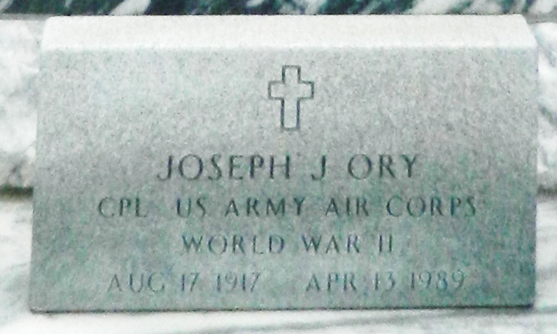

SSDI: JOSEPH J ORY 17 Aug 1917 13 Apr 1989 (not specified) (none specified) xxx Louisiana

U.S., Department of Veterans Affairs BIRLS Death File, 1850-2010
Name Joseph Junius Ory
Gender Male
Birth Date 17 Aug 1917
Death Date 13 Apr 1989
Cause of Death Natural
SSN xxx
Enlistment Branch Army
Enlistment Date 29 Aug 1942
Discharge Date 6 Sep 1945
Page number 4

