Joseph Marie Ory
September 9, 1888 – November16, 1962

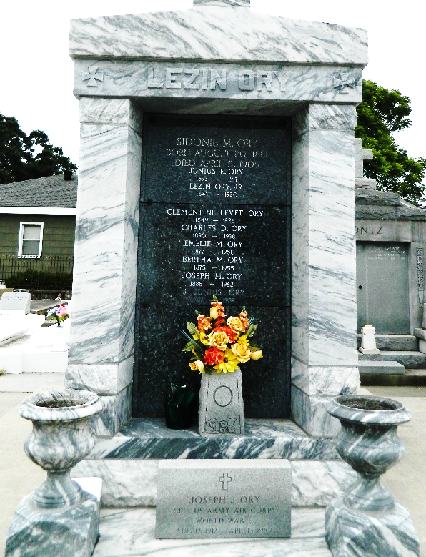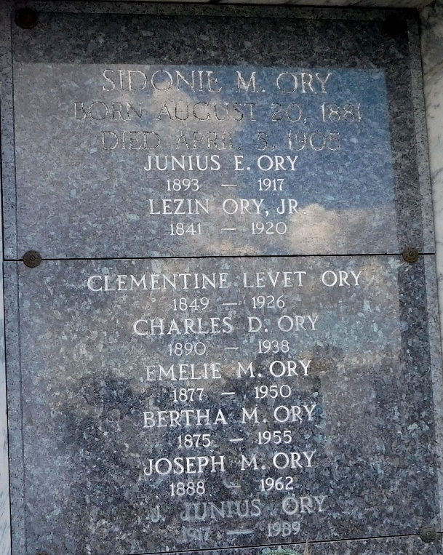

Died at Hotel Dieu Hospital, New Orleans, age 74 years, a native of Assumption Parish, Louisiana, and a resident of Reserve, Louisiana.
Husband of Esther Lasseigne and father of Mrs. Francis Fulton of Laplace, Louisiana, and Junius Ory of Laplace, Louisiana.
Services were Saturday, 17 Nov 1962 at St. Peter Church, Reserve, with interment in St. Peter Cemetery.
The Times-Picayune, New Orleans, Louisiana
17 Nov 1962

