Junius Emile Ory
August 20, 1893 – January 4, 1917

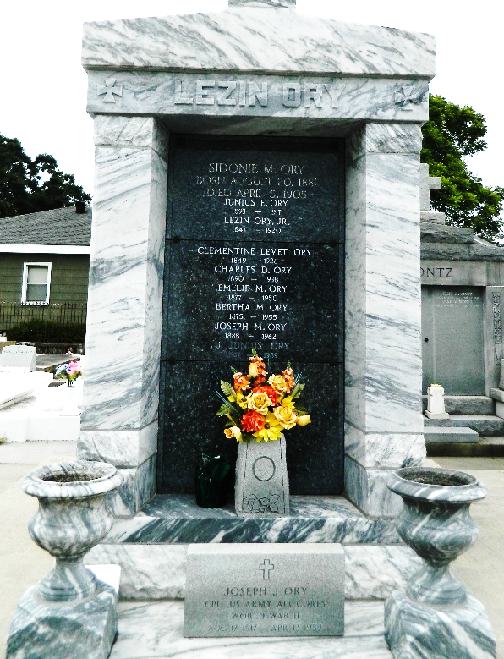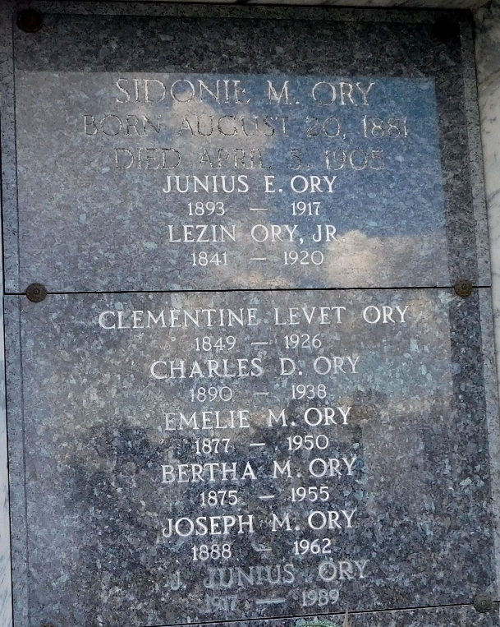

Age 23, a native of Assumption Parish, Louisiana. He was the youngest son of Mr. and Mrs. Lezin Ory of Lions, Louisiana. Survived by his parents and sisters Mrs. Louis Caboche, Misses Bertha and Emelie Ory, and brothers Joseph and Charles Ory.

Services were Thursday, 4 Jan 1917 at St. Peter Church in Reserve, Louisiana, with interment in St. Peter Cemetery.
The Times-Picayune, New Orleans, Louisiana
January 8, 1917

