Leonie (LeBlanc) Ory
July 19, 1886 – December 12, 1972

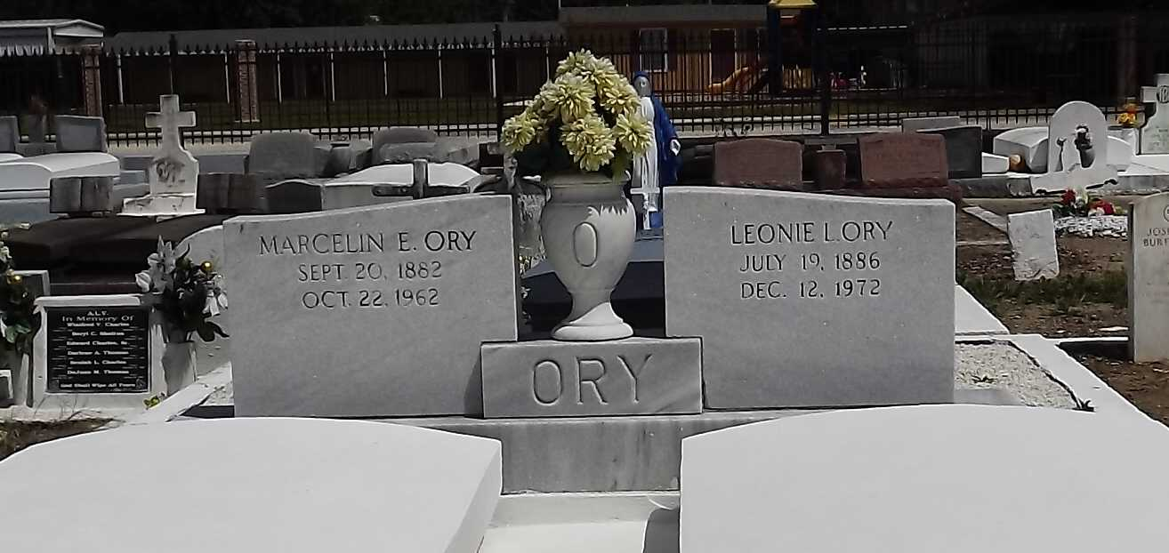
Photo by Mary Agnes hammett

Mrs. Leonia LeBlanc Ory, on Tuesday, December 12, 1972, at 8:25 o’clock a.m.; wife of the late Marcelin Ory; mother of Mrs. Emie (Leontine) O. Gras of Norco, La.; sister of the late Leopold LeBlanc Sr., also survived by 5 grandchildren, age 86 years, a native of St. James Parish and a resident of Norco, La. for the past 23 years.
Relatives and friends of the family, also employees of Shell Oil Co., are invited to attend the funeral. Services from H. C. Alexander Funeral Home, Ind., 821 Fourth St., Norco, La., on Thursday, December 14, 1972 at 10:00 o’clock a.m. Religious services at Sacred Heart of Jesus Catholic Church. Interment in St. Peter’s Cemetery, Reserve, La. Recitation of the Rosary by the Holy Name Society Wednesday at 7:30 p.m. and by the Ladies Altar Society Thursday at 9:15 a.m. Parlor will be open at 6 p.m.

The Times-Picayune, New Orleans, Louisiana
Wednesday, December 13, 1972, section 1, p. 12

