Leontine Ory
August 18, 1874 – December 7, 1937

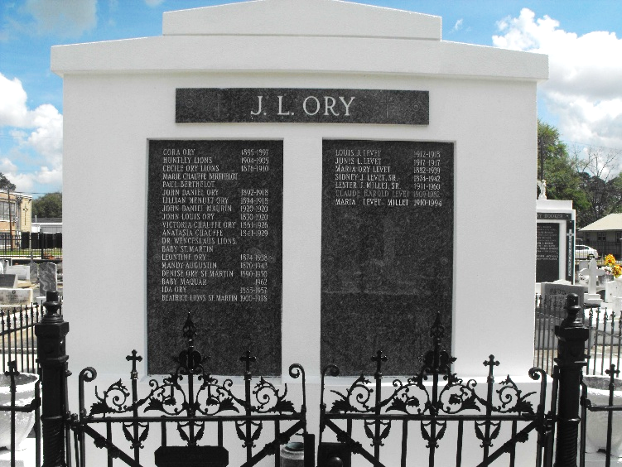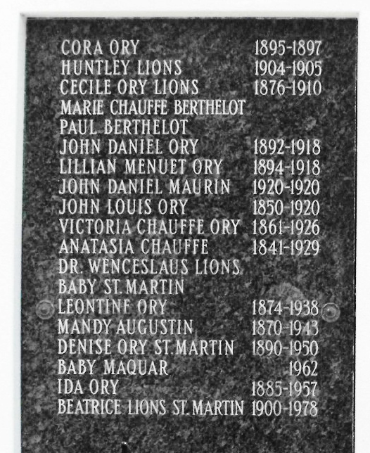
Photos by Mary Agnes Hammett

ORY - At Laplace, La, at home of her sister, Mrs. Charles St. Martin. On Tuesday, December 7, 197, at 10:25 o'clock a.m., MISS LEONTINE A ORY, native of St. John parish, daughter of the late John L. Ory and the late Victoria Chauffe Ory; sister of Mrs. Sidney J. Levet of Lions, La., Miss Ida Ory of Lions, La., Mrs. Henry C. Maurin of Laplace, La., and Mrs. Charles St. Martin of Laplace, La.

Relatives and friends of the family are invited to attend the funeral which will take place from the Millet Funeral Home at Reserve, La, on Wednesday, December 8, 1937, at 10:30 o'clock a.m., with services at St. Peter's Catholic Church, Reserve, La. Interment in St. Peter's cemetery.

The Times-Picayune, New Orleans, Louisiana
December 8, 1937, p. 2

