Louisa (Vicknair) Ory
April 2, 1885 – August 25, 1968

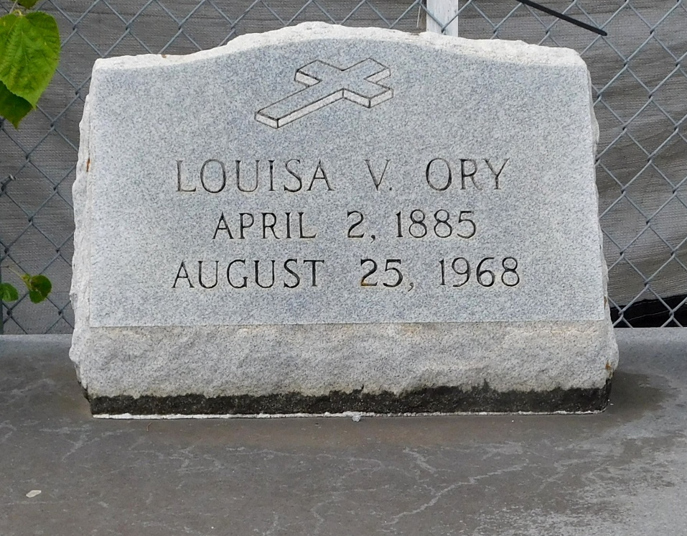
Photos by Mary Agnes Hammett

Age 83 years, a native of St Charles Parish, Louisiana, and a resident of Mt. Airy, Louisiana, for 77 years. Wife of the late Emilien Ory, mother of Miss Eva M. Ory of New Orleans, Misses Ernestine R. and Mabel A. Ory, Mrs. Ida Smith, Mrs. Charles St. Pierre, all of Mt Airy, Mrs. G. L. Babin of Lutcher, Louisiana, Mrs. Joseph Lemoine of Jackson, Mississippi, and Raymond Ory of Gramercy, Louisiana.

Services were Tuesday 27 Aug 1968 at St Hubert Church, Garyville, Louisiana, with interment in St Peter Cemetery, Reserve, Louisiana.

The Times-Picayune, New Orleans, Louisiana
August 26, 1968

