M. Adora (Chauffe) Ory
March 24, 1859 – November 23, 1922

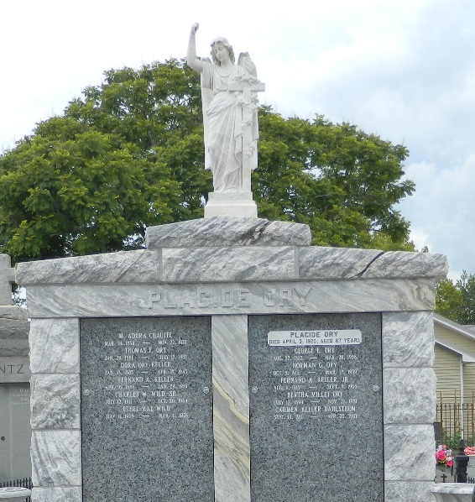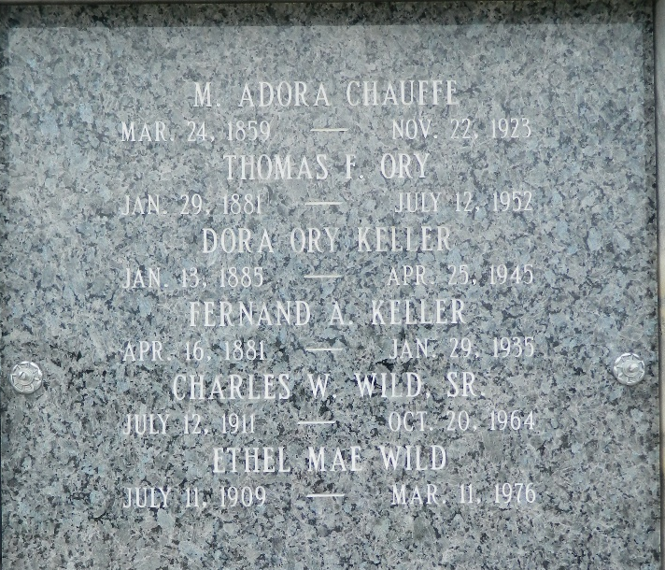

ORY - At the residence of Dr. F. A. Keller, 2824 Octavia street, New Orleans, La., on Thursday, November 23, 1922, at 3 o'clock a.m., MRS PLACIDE ORY (nee Adora Chauffe), beloved wife of the late Placide Ory and mother of Thomas of New Orleans, La., George and Joseph Ory of Baker, La., and Mrs. F. A. Keller of New Orleans, La, aged 63 years and 8 months, a native of Lafourche Parish, La, and a resident of this city three years. The relatives and friends of the family are respectfully invited to attend the funeral, which will take place from St Peter's Church, Reserve, La, after the arrival of the Y and M V morning train from New Orleans, La, Friday, November 24, 1922. Interment in Reserve (La) Cemetery.

The Times-Picayune, New Orleans, Louisiana
November 24, 1922, p. 2
**

Marie Adora Chauffe [Thomassin and Clonise Maillet] born March 24, 1859, bt. July 8, 1859, spo. Theodule Chauffe and Seraphine Gros [ASM-13,91]

Diocese of Baton Rouge Catholic Church Records, Volume 9, page 124.

