Marie Alida (Perilloux) Ory
August 26, 1895 – July 20, 1915

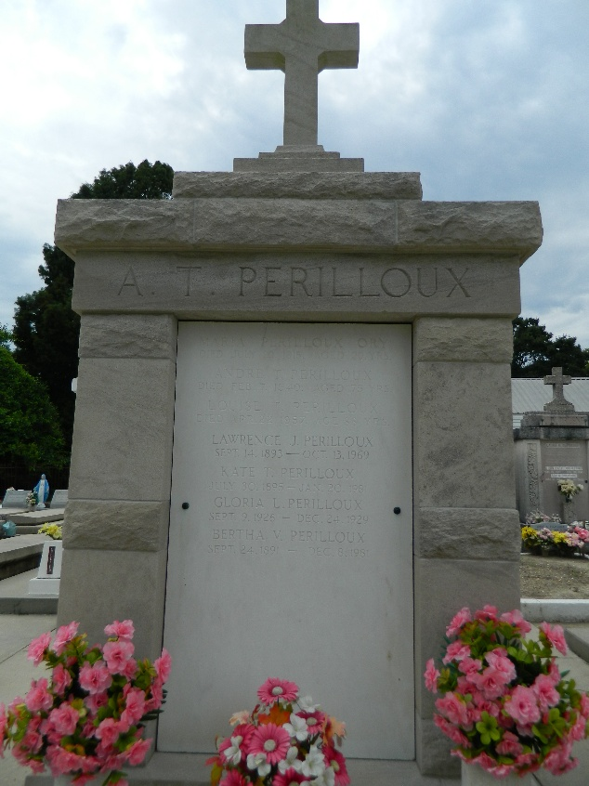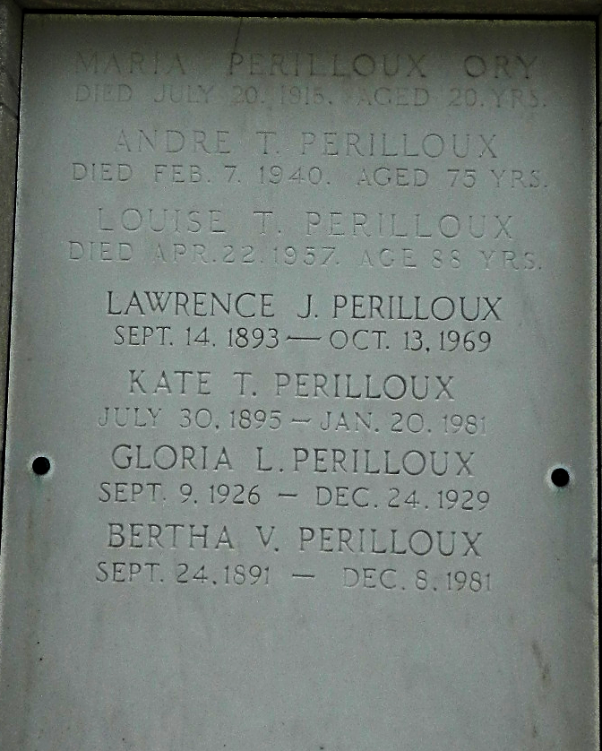

Marie Alida Perilloux, Mrs. John Daniel Ory, died in Laplace, Louisiana, on Tuesday, 20 July 1915 at 9:45 a.m. at age 19 years, 10 months and 24 days. She was a native and lifetime resident of St John the Baptist Parish, Louisiana.
She leaves her husband, to whom she was married for but thirteen months, her parents, Mr. and Mrs. A[ndre] T. Perilloux, a brother, Lawrence and two sisters, Bertha and Blanche Perilloux.
Funeral services were held Wednesday 21 July 1915 at St Peter Church, Reserve, Louisiana, with Rev F Badeaux officiating. Interment was in St Peter Cemetery, Reserve.

The Times-Picayune, New Orleans, Louisiana
July 21 & 23, 1915

