Marie Eliza (Tregre) Ory
November 15, 1856 – March 2, 1940

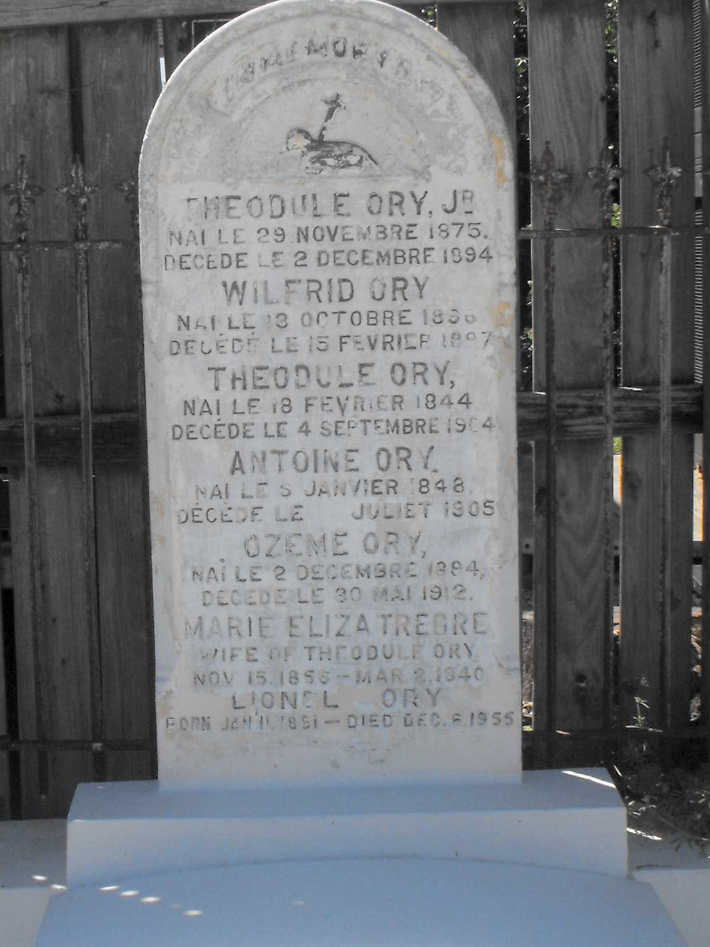
Photo by Mary Agnes Hammett

Died at Mt. Airy, LA, on Saturday, 2 Mar 1940, at age 83 years and 3 months. Wife of late Theodule Ory and mother of Mrs. Fernand (Nemea) Vicknair and Marcelin Ory of Mt. Airy, Mrs. John (Elvire) Lambert, Mrs. Freddie (Sidonie) Lohman [Sidonie had a first marriage to Septime Richard], Lionel and Abel Ory of New Orleans, and Mrs. W. H. Jackson of Houston, TX.

Services were Monday, 4 Mar 1940, at St Hubert Church, Garyville, LA, with interment in St Peter Cemetery, Reserve, LA.

The Times-Picayune, New Orleans, Louisiana
March 3, 1940, p. 6

