Mary Noelie (Dufrene) Ory
December 26, 1880 – November 8, 1944

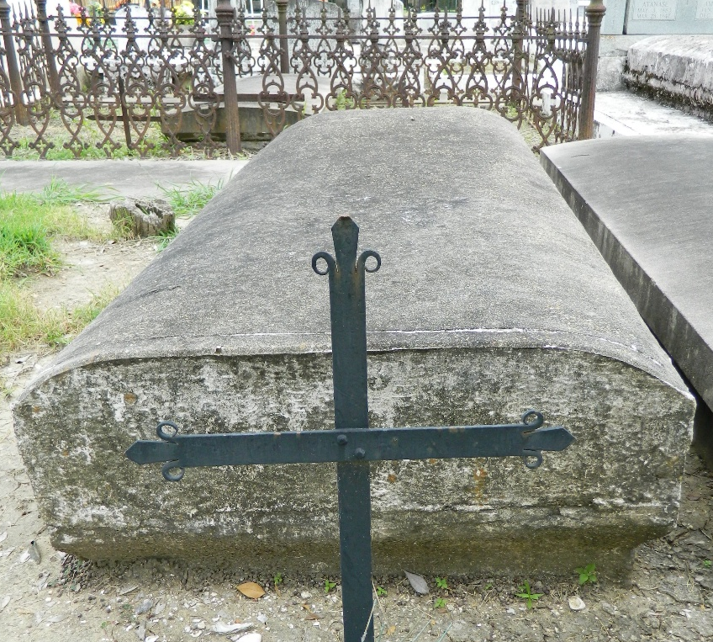

Mrs. Mary Noelie Ory, wife of the late Uger Ory, died Wednesday, 8 Nov 1944, at age 63 years, 10 months and 12 days. She was the mother of Archangel Ida Ory of Los Angeles, CA., Sister Mary Sebastian Jeanne of New Orleans, LA., Stanley Ory of Fort Worth, TX., Hayward Ory of Nashville, TN., Sanders Ory of San Diego, CA., Paul Ory of Mobile, AL., J D Ory of Ama, LA., Lee Ory of the U. S. Army and Joseph Ory of the U. S. Marines.
She was the sister of Edward Dufrene of New Orleans and Mrs. Frank Furtado of New Orleans. She was a native and life long resident of St James Parish, LA.
Funeral services were Friday, 10 Nov 1944 at St James Catholic Church, St James, Louisiana, with interment in St Peter Cemetery, Reserve, Louisiana.

Unknown source

