Omer A. Ory Jr.
September 24, 1914 – November 11, 1976

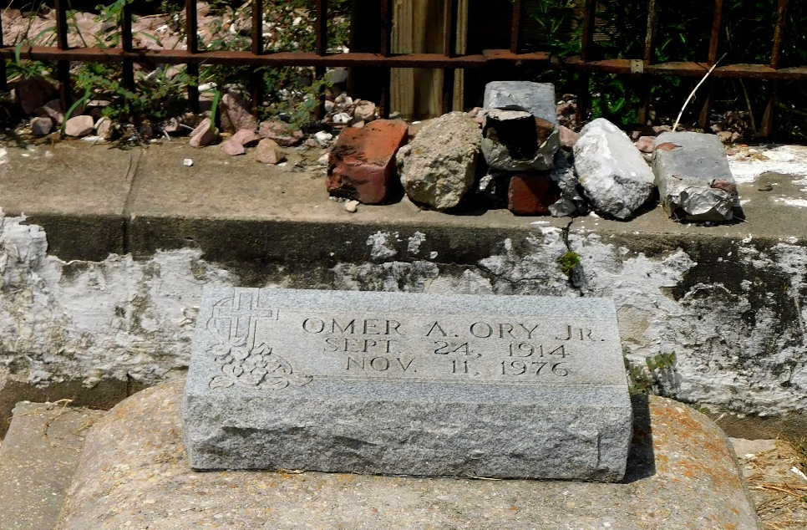
Photo by Mary Agnes Hammett

ORY – Omer A. Ory, Jr. on Thursday, November 11, 1976 at 9:45 a.m., beloved husband of Mrs. Helen Landry Ory of New Orleans, La.; father of Donald J. of Chalmette, La., Clyde A. of Violet, La., Merlin J. of Kenner, La. and Glen J. Ory of New Orleans, La.; also survived by 5 grandchildren; Age 62 years, a native of Garyville, La., and a resident of New Orleans, La. for the past 35 years.
Relatives and friends of the family are invited to attend the funeral services from Millet Funeral Home, Reserve, La. on Saturday, November 13, 1976, at 9:30 a.m. followed by religious services at St. Huberts Catholic Church, Garyville, La., at 10 a.m. Interment in St. Peters Cemetery. Friends may call from 5 p.m. to 11 p.m. on Friday, November 12, 1976 and from 8 a.m. until services on Saturday, November 13, 1976.

New Orleans States-Item, Louisiana
Friday, Nov. 12, 1976, p. 10

