Victoria (Chauffe) Ory
December 7, 1855 – September 5, 1926

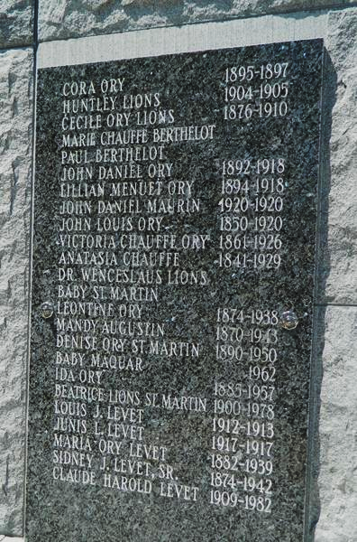

ORY - On Sunday morning, Sept 5, 1926, at 9:35 o'clock, VICTORIA CHAUFFE, in her seventieth year, wife of the late John L. Ory and mother of Mrs. S[idney] J. Levet, Mrs. Henry C. Maurin, Mrs. Charles St. Martin, Leontine and Ida Ory, also grandmother of Elmer Lions and Mrs. Robert St. Martin. The cortege will leave the residence, No 15 Audubon Boulevard, at 2 o'clock Monday afternoon, followed by services at St Peter's church, Reserve, La, at 4 o'clock.

NOTE: Tomb inscription has her birth as "1861", however her baptismal record shows her birth as 7 Dec 1855.

Researched by Dwayne Montz

