Cecile (Lieteau) Oubre
November 15, 1925 – December 29, 2016

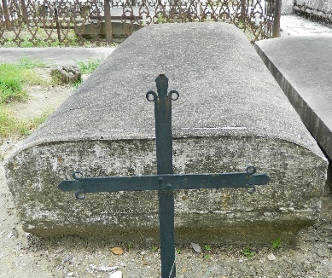

Cecile Lieteau Oubre (affectionally known by all as "Maw Maw") passed away from her earthly home to her heavenly home on December 29,2016, at the age of 91 yrs. She was born in Mt. Airy Louisiana, to parents John Phillip Lieteau and Maria Octavia Labostrie. She was married for 67 glorious years to the late Henry Oubre, leaving behind seven children, Oneal Oubre (Leora), Patrick Oubre, Maureen Oubre, Scarlette Oubre-Charles (Hammond), Bryant Oubre (Julia), Fergus Oubre (Demetria), Cornelia Oubre-Solis(Julian) and Kimberly Oubre-Dural (Dalton) whom she reared. She is also survived by 14 grandchildren, 22 great-grandchildren, 1 great-great-grandchildren and a host of nieces, nephews, friends and the Garyville neighborhood children.
Mrs. Oubre was preceeded in death by her son Shawn Oubre and daughters Jennifer Oubre and Cordelia Oubre, her brothers Phillip Lieteau, Robert Liteau, Raymond Lieteau, Herbert Lieteau and her sisters Marie Deselle, Evelyn Lieteau and Theresa Lieteau.
Relatives and friends of the family, neighbors, members of St. Hubert Catholic Church and VFW Post 3337 Ladies Auxillary are invited to attend a Mass of Christian Burial on Friday, January 6,2017 at St. Hubert Catholic Church,176 Anthony F Monica St., Garyville La 70051 at 11:00am. Visitation and Rosary begins at 9:00am. Burial will be at St. Peter's Cemetery, 1550 Highway 44, Reserve, La 70084. Professional arrangements entrusted to Bardell's Mortuary of Mount Airy, La.

TheNewOrleansAdvocate.com
Jan. 4 to Jan. 7, 2017

