Coleman Hubert Oubre
August 5, 1937 – February 6, 2020

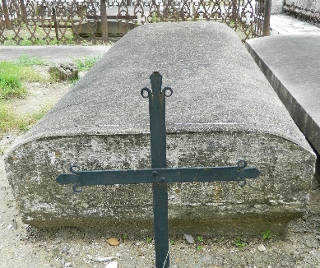

Coleman Hubert Oubre, age 82, passed away peacefully at his home surrounded by family on Thursday, February 6, 2020. He was born on August 5, 1937 in New Orleans, LA. He was a resident of Reserve, LA and is preceded in death by his parents, Calogera and Hubert Oubre.
He is survived by his wife, Sheila Montz Oubre; his children, Kelly Oubre, PJ (Katie) Oubre, Amber (Jason) Salvadras; his step-children, Kristie (Brandon) Pickering, Nickolas (Myra) Guarneri; grandchildren, Jonathan, Nickolas Jr., Evan, Lacie, Ethan, Giada, Giovanni and Gino; his siblings Clair, Penny, Odile, Anna, Hubert, Johnny, Andrea, Danny and Sharon; and a host of nieces and nephews. Coleman was a grateful member of Alcoholics Anonymous for almost 32 years. He also proudly served in the US Navy.
Visitation will be held from 9:00am – 11:00am at St. Peter Church, 1550 LA-44, Reserve, LA on Monday, February 10, 2020, followed by a Memorial Mass at 11:00am. A bereavement gathering will follow at the Knights of Columbus Hall, 114 W 7th St., Reserve, LA. In lieu of flowers, a memorial contribution may be made to Perry's Posse, Inc. (perrysposse.org or mail to Perry's Posse, PO Box 2053, Garyville, LA 70051), in memory of Coleman.
The Times-Picayune, New Orleans, Louisiana
Feb. 8 to Feb. 10, 2020

