Eliza Anna (Zeringue) Oubre
January 8, 1926 – September 7, 2012

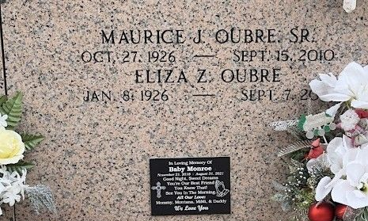
Photo by Team T-Lo

Eliza Zeringue Oubre passed away on Friday September 7, 2012.
Beloved wife of the late Maurice Oubre Sr. Mother of Shannon Bier, Maurice Oubre Jr. (Peggy) and the late Ronnie Oubre (Donna). Also survived by 5 grandchildren and 9 great-grandchildren. Sister of Lillian Audifred, Noelie Roussel and the late Ida Barre and Earline Weber. Age 86. A native of Gramercy, LA and a resident of Reserve, LA.
Relatives and friends are invited to attend services. Visitation at St. Peter Catholic Church, Reserve, LA on Monday September 10, 2012 from 9:00 am to 11:00 am, followed by Mass at 11:00 am. Burial in St. Peter Cemetery. Arrangements by Millet-Guidry Funeral Home, LaPlace, LA.

The Times-Picayune, New Orleans, Louisiana
Sep. 7 to Sep. 9, 2012

