Emilie (LeBoeuf) Oubre
October 7, 1892 – July 10, 1971

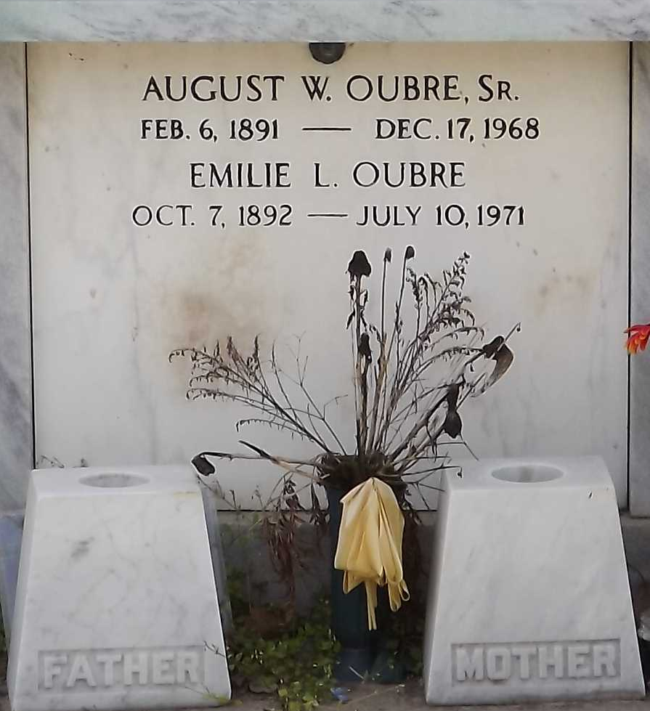
Photo by Mary Agnes Hammett

OUBRE, MRS. EMILIE LEBOEUF

Died at 1 a.m. Saturday at the hill haven rest Home No. 2, Baton Rouge. She was 78, a native of St. James and a resident of Garyville for 59 years.
Body at Millet Funeral Home, Reserve, with visitation after 3:30 p.m. Sunday. Services at 10:30 a.m. Monday at the funeral home, followed by religious services at 11 a.m. Monday at St. Hubert’s Catholic Church, Garyville. Interment in St. Peter’s Cemetery, Reserve.
Survived by six sons, Calvin and Raymond Oubre, both of Baton Rouge; August Oubre Jr., Princeton, Ind.; Gayle, Melvin and George Oubre, all of Garyville; three daughter, Mrs. Joe (Eunice) LeBeau, Baton Rouge; Mrs. Pershing (Rita) Berthelot, Gramercy; and Mrs. Wilbert (Therese) Ocmond, Garyville; 20 grandchildren and 13 great-grandchildren.
Preceded in death by her husband, August W. Oubre, and a son, Leroy Oubre. She was a member of St. Huber’s Altar Society.

The Advocate, Baton Rouge, Louisiana
Sunday, July 11, 1971, p. 4-B

