Gladys Marie (Alexander) Oubre
February 7, 1953 – November 11, 2024

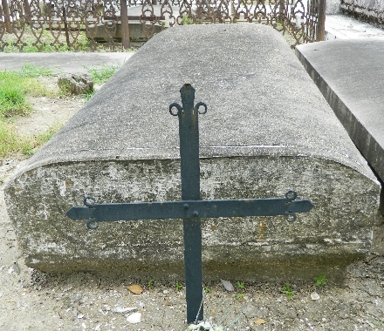

Gladys "Marie" Alexander Oubre departed from this Earth peacefully on Monday, November 11, 2024, at the age of 71. Marie was born on February 7, 1953, to the late Marshall and Alma Carter Alexander. She was a native and lifelong resident of LaPlace, LA. Marie was united in marriage to Rickey M. Oubre on November 3, 1979. Their union of over 45 years was blessed with one daughter, Nylyn Rae Marie Oubre, who became the center of her world.
Marie was academically gifted. She was educated in the St. John the Baptist Parish Public School System and graduated from Leon Godchaux High School in Reserve, LA. Upon graduation, she attended Louisiana State University, where she excelled and graduated with a degree in Business Administration. Her career spanned 29 years at Monsanto Chemical Plant in Luling, LA, where she worked diligently, rising to the position of Office Administrator.
Marie's spirit was one full of life, joy, and a love fierce enough to weather any storm. Her kindness touched the lives of everyone around her. She was steadfast in her devotion to her loved ones and could even make a stranger feel as though they had known each other for years. Her warmth and wisdom drew people to her. Recognized for her generous heart and unwavering support, she was a source of strength for her family and friends. Marie had a profound impact on her community, always willing to lend a helping hand or a listening ear. Her legacy of compassion and dedication to helping others will be remembered by all who knew her.
She is survived by her loving husband, Rickey M. Oubre, her cherished daughter, Nylyn Rae Marie Oubre, her dearly loved sister, Myrtle Alexander Lennix, her brothers Curtis Alexander (Vicky) and Marshall Alexander, Jr. (Suezane), her sisters-in-law JoAnn Perdue (Joe), Linda Oubre Johnson, and Tally Weber Greene (Melvin), her brother-in-law, James Sammy Oubre, Jr. (Carolyn), her God-Daughter, Raven Symone' Simmons, and a host of nieces, nephews, cousins, other relatives and friends who will miss her dearly.
She was preceded in death by her parents, Marshall and Alma Carter Alexander, her mother-in-law and father-in-law Mildred Legaux Oubre Weber, James Sammy Oubre, Sr., and Melvin Weber, her brother and her sister Raymond Alexander and Elaine LaGrande, and her sister-in-law and brothers-in-law Dianne Alexander, Allen Lennix, Sr., and Raymond LaGrande.
Marie's life was a testament to the power of kindness and the importance of community. She will forever be remembered for her warmth, intelligence, and the love she shared with those around her. Marie will be deeply missed but forever cherished in our hearts.
Relatives and friends of the family, employees of Monsanto, employees of Evonik, and employees of the Department of the Navy are invited to attend the Visitation and Funeral Mass on Tuesday, November 19, 2024, at St. Joan of Arc Catholic Church, 529 W 5th St, Laplace, LA 70068. Visitation from 9:30 a.m. – 11:00 a.m., with a Mass of Christian Burial to follow for 11:00 a.m. Interment St. Peter's Catholic Church cemetery, Reserve, LA.

Treasures of Life Funeral Services, Gramercy, Louisiana

