George A. Oubre
September 4, 1929 – February 5, 2015

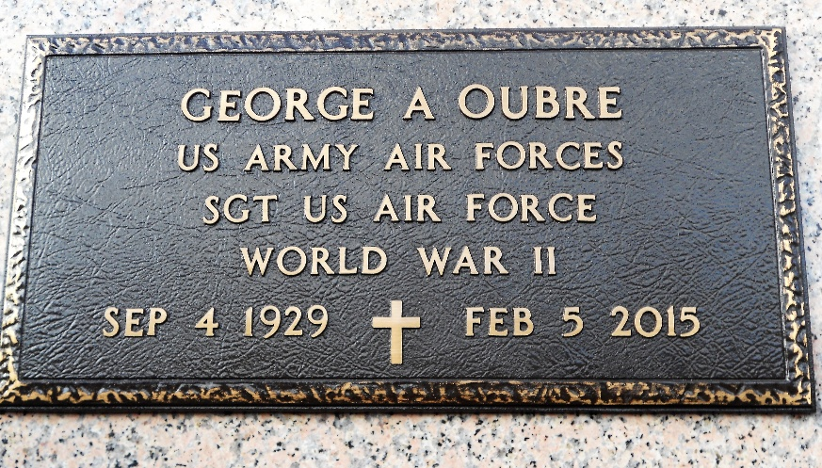
Photo by Team T-Lo

Mr. Oubre of Gonzales, Louisiana, died Thursday, February 5, 2015. He was the son of the late August and Emilie (LeBouef) Oubre. Mr. Oubre was a native of Garyville, Louisiana, and resident of Gonzales, Louisiana. He was graduate of Leon Godchaux High School in Reserve, Louisiana, and Northwestern State University in Natchitoches, Louisiana.
Mr. Oubre was of the Catholic faith and was an active member of the St. John the Evangelist Knights of Columbus Council 8342. He was also active in the Church Usher Society. He was a veteran of the US Air Force and honorably discharged as a sergeant following World War II.
Mr. Oubre is survived by his wife of 32 years: Mary Trosclair Oubre; 7 children: Christy Frederic of Pineville, Louisiana; Joan F. LeBouef and her husband: Terry of Garyville, Louisiana; Kenton Frederic of Gonzales, Louisiana; Alexis F. Gaudette and her husband: Marc of Richmond, Virginia; Maria F. Treece and her husband: Perry of Port Vincent, Louisiana; AJ Frederic of Slidell, Louisiana, and Keith Frederic of Gonzales, Louisiana; his wonderful grandchildren: Jeremy, Joey and Jason Lebouef; Alex Gaudette and Allison Treece; 1 sister: Rita Berthelot of Franklinton, Louisiana; 1 brother-in-law: Ray Trosclair of St. Amant, Louisiana; 1 sister-in-law: Audrey T. Millet of Garyville, Louisiana.
He was preceded in death by his parents August and Emilie LeBouef Oubre and his brothers Melvin, Calvin, August, Leroy, Raymond and Gayle Oubre, and sisters Eunice LeBeau and Therese Ocmand.
Funeral services will be held Tuesday, February 10 at 11:00 a.m. for George A. Oubre, age 85, at St. John the Evangelist Catholic Church (15208 Hwy 73, Prairieville, LA 70769) with Father Jerry Martin presiding. Friends may visit at the church from 9:30 a.m. until time of Mass. Burial will follow at St. Peter's Catholic Church Cemetery in Reserve, Louisiana. Father John Marse presided over the Christian burial.
The Advocate, Baton Rouge, Louisiana
6 Feb. 2015

