Geraldine Marie (Trosclair) Oubre
November 29, 1941 – January 1, 2024

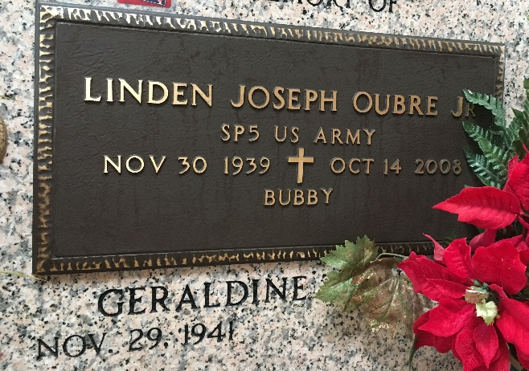
Photo by Team T-Lo

Geraldine Marie Trosclair Oubre passed away on Monday, January 1, 2024 at the age of 82. She was a native and a life-long resident of Reserve, LA and was retired from the St. John the Baptist Parish School Board after 38 years of service.
Beloved wife of the late Linden “Bubby” Oubre, Jr. Loving mother of Donna Oubre Weber, Lynn Oubre Caronna (Nick), Ann Oubre Scallan (Mike), Linden Joseph “Joey” Oubre, III (Donna H.) and Julie Oubre Snyder.
Daughter of the late Elvest Trosclair and Rose Marie Hymel Trosclair. Sister of Gloria Trosclair Allen (Merlin Jay), Janice Trosclair Keating (Kenneth), Anna Lee Trosclair Entremont (Kenneth) and the late Phyllis Trosclair Heddings (Gene). Sister-in-law of Cheryl Oubre Triche and the late Mary Oubre Becnel. Daughter-in-law of the late Mr. and Mrs. Linden Oubre, Sr. Also survived by 11 grandchildren, 8 great-grandchildren and many nieces and nephews. She was preceded in death by her grandchild, Nicholas Caronna.
Relatives and friends are invited to attend the Visitation and Funeral Mass at St. Peter Catholic Church, 1550 Hwy 44, Reserve on Saturday, January 6, 2024. Visitation will be held at the church from 9:00 a.m. to 11:00 a.m. followed by a Funeral Mass at 11:00 a.m. Interment in St. Peter Cemetery, Reserve, LA.
Rose Lynn Funeral Home, Lutcher, Louisiana

