Julia (Guidry) Oubre
December 29, 1917 – May 2, 2008

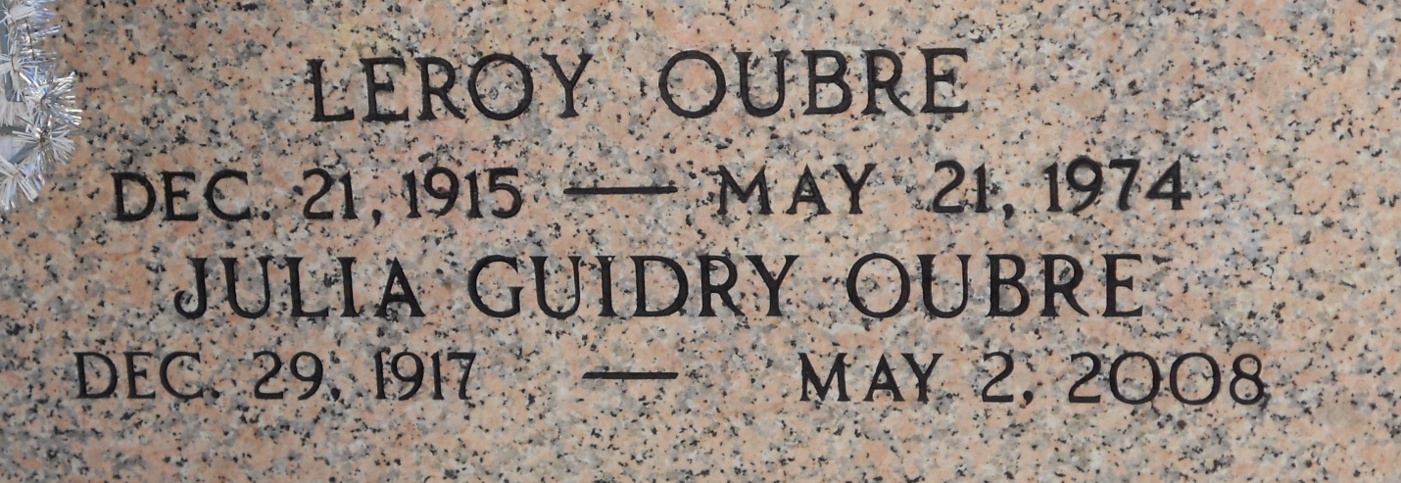
Photo by Team T-Lo

A native and resident of Garyville, she passed away on Friday, May 2, 2008, at Ormond Nursing and Care Center in Destrehan at age 90.
Visiting at St. Hubert Catholic Church, Garyville, on Tuesday, May 6, from 9 a.m. until religious service at 11 a.m. Burial in St. Peter Cemetery in Reserve.
She was the wife of the late Leroy J. Oubre, mother of Melanie Oubre and Dayna O. Sullivan, both of LaPlace and Stephen Oubre and wife Alice, of Prairieville, grandmother of Michael and wife Sara, Philip and Robert Oubre, sister of Marie A. Guidry and the late Richard and Harry Guidry, daughter of the late Louella Tamplain and Robert Guidry.
The family wishes to thank her caregivers at Ormond, St. Catherine's Hospice and Egan Health Care.
Arrangements by Millet-Guidry LLC Funeral Home in LaPlace.

The Advocate, Baton Rouge, Louisiana
May 4, 2008

