Kevin Oubre
April 4, 1963 – September 9, 2025

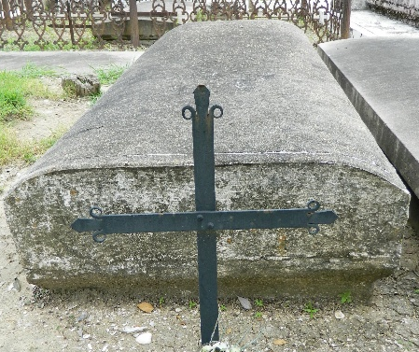

Kevin "Oot" James Oubre passed away on Tuesday, September 9th, 2025 at the age of 62. He was born in New Orleans and was a resident of LaPlace.
Beloved father of Gabrielle "Gabby" Jacqueline Oubre. Son of James "Toot" Oubre and the late Sandra Vilemont Oubre. Brother of Dawn Schexnayder (Michael). Uncle of Ryan Monica, Lauren Dye, Catherine Masters, Erin Bourgeois, and Shannon Monica. Cherished friend of many.
Anyone that knew Kevin knows that his love for the great outdoors wasn't just a hobby; it was a way of life, and he spent every possible moment outside, exploring the world he cherished. Whether it be trawling out on his boat on Lake Pontchartrain or hunting in the winter seasons, you'd know he found solace appreciating nature and God's creatures. His daughter and his family were his greatest pride. He taught them to appreciate the value of hard work, dedication, and to respect all living things. Kevin was a loyal friend and compassionate soul who would go out of his way to lend a hand or offer his knowledge to those around him.
Relatives and friends are invited to attend the Visitation and Funeral Mass at St. Joan of Arc Catholic Church, 529 W. 5th Street, LaPlace, LA on Monday, September 15, 2025. Visitation will be held from 10:30 a.m. until 12:30 p.m. followed by a Funeral Mass at 12:30 p.m. Interment in St. Peter Cemetery, Reserve, LA.

Obituary published on Legacy.com by Millet-Guidry Funeral Home - LaPlace on Sep. 13, 2025

