Linden Joseph Oubre Jr.
November 30, 1939 – October 14, 2008

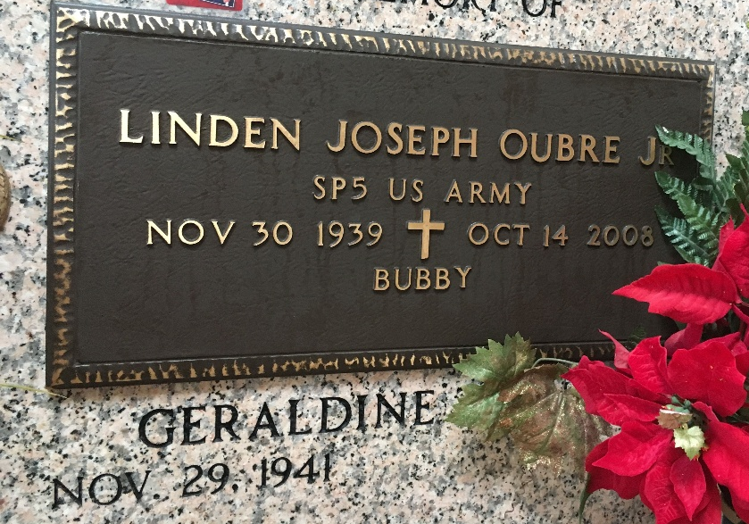
Photo by Team T-Lo

Linden "Bubby" "L.J." Oubre Jr. entered eternal life at 5 p.m. Tuesday, Oct. 14, 2008. He was 68 and a native and resident of Reserve.
He was the beloved husband of Geraldine Trosclair Oubre, and father of Donna Weber, Lynn Caronna and husband Nick, Ann Scallan and husband Mike, Linden "Joey" Oubre III and wife Donna, and Julie Snyder and husband Johnny. Also survived by 11 grandchildren.
Preceded in death by his parents, Linden "Bilbo" Oubre Sr. and Josephine Oubre; and a grandchild. He was the son-in-law of Rose Trosclair and the late Elvest Trosclair, and brother of Cheryl Triche and Mary Ann Becnel. Also survived by his beloved dog, Chance.
Relatives, friends and employees of Western-Southern Life Insurance Co. are invited to attend services. Visitation at Millet-Guidry Funeral Home, 2806 W. Airline Highway, LaPlace, on Thursday, Oct. 16, from 5 p.m. to 9 p.m. Visitation at St. Peter Catholic Church, Reserve, on Friday from 9 a.m. until religious service at 10 a.m. Burial in St. Peter Cemetery.

The Advocate, Baton Rouge, Louisiana
Oct. 16, 2008

