Maurice Joseph Oubre Sr.
October 27, 1926 – September 15, 2010

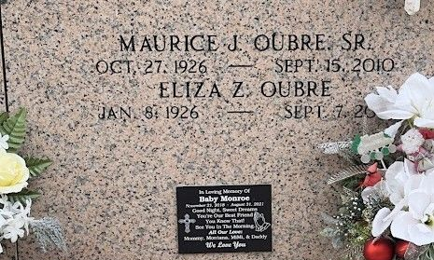
Photo by Team T-Lo

Maurice J. Oubre, Sr. passed away on Wednesday, September 15, 2010.
Beloved husband of Eliza Zeringue Oubre. Father of Ronnie Oubre and wife Donna, Shannon Bier, and Maurice Oubre Jr. and wife Peggy. Also survived by 5 grandchildren and 8 great-grandchildren. Age 83. A native of Gramercy, La. and a resident of Reserve, La.
Relatives and friends are invited to attend services. Visitation at St. Peter Catholic Church, Reserve, La. on Friday, September 17, 2010 from 9:00 AM to 11:00 AM. Followed by Mass at 11:00 AM. Burial in St. Peter Cemetery. Arrangements by Millet-Guidry Funeral Home, LaPlace, La.

The Times-Picayune, New Orleans, Louisiana
September 17, 2010

