Odile (Luquette) Oubre
October 7, 1882 – February 4, 1984

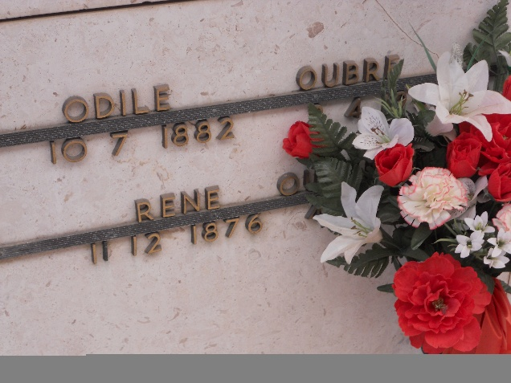
Photo by Team T-Lo

OUBRE

Odile Oubre, on Saturday, February 4, 1984, at 4:45 o’clock p.m., at Twin Oaks Nursing Home, LaPlace, wife of the late Rene Oubre, Sr., daughter of the late Joseph Luquette and Constantine Kliebert, mother of Armantine Kliebert, Garyville, La., Rene Oubre, Sr., Richard Oubre, Sr., all of Garyville, La.; also survived by 31 grandchildren; age 101 years; a native of Vacherie, La. and a resident of Garyville, La. for a number of years.
Relatives and friends of the family, also officers and members of the St. Hubert Altar Society are invited to attend the funeral service from the Alexander Funeral Home, 107 Jefferson Hwy., Lutcher, La., on Monday, February 6, at 2 o’clock p.m. Religious services at the St. Hubert Catholic Church, Garyville, La. Interment in the St. Peters Mausoleum, Reserve, La. Friends may call on Monday from 8 a.m. until service time.

Unknown newspaper clipping

