Oliver Marcel Oubre Jr.
January 19, 1899 – October 3, 1981

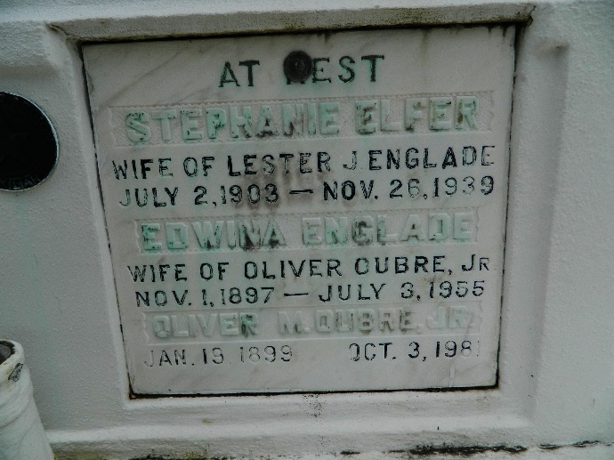

OUBRE
Oliver M. Oubre Jr., on Saturday, October 3, 1981, at 4:30 a.m., beloved husband of the late Edwina Englade, father of Allen, Alvie, Richard, and Ronald Oubre, also Iris Develle, Eula Boudreaux, and Cynthia Vicknair; son of the late Mr. and Mrs. Oliver Oubre Sr., brother of Mrs. A. J. Weber, and the late Walter, Aristide, and Lauren Oubre; also survived by 26 grandchildren, and ? great-grandchildren, age 82 years, a native of Edgard, and a resident of Metairie for the past 12 years.
Relatives and friends of the family are invited to attend the funeral. Services from Millet Funeral Home, Reserve, Louisiana, on Monday, October 5, 1981 at 9:30 a.m., followed by religious services at St. Peter Catholic Church. Interment in the Church Cemetery. Friends may call from 5 until 10 p.m. Sunday, October 4, 1981, and from 8 a.m. until services on Monday.

Unknown newspaper clipping

