Ricky Peter Oubre
July 16, 1952 – April 20, 1973

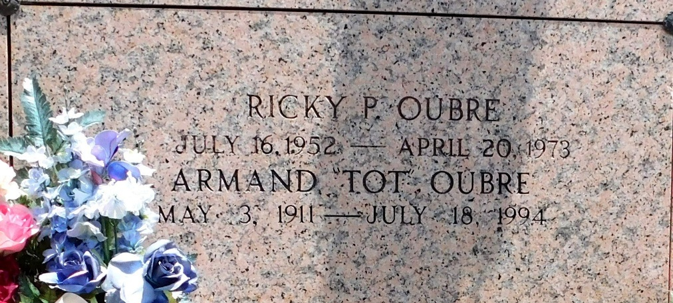
Photo by Mary Agnes Hammett

OUBRE

Ricky Peter Oubre of Reserve, Louisiana, on Friday, April 20, 1973, at 7:00 o’clock p.m., son of Armand Oubre and Bell Canova; brother of Joseph Anthony Oubre and Mrs. Harold (Judy) LaFontaine of Reserve, La., and Mrs. Gerald (Gloria) Hotard of Norco, La., age 20 years, a native and resident of Reserve, La.
Relatives and friends of the family are invited to attend the funeral. Services from Millet Funeral Home, Reserve, La., on Tuesday, May 1, 1973, at 10:00 o’clock a.m. Religious services at St. Peter Church, Reserve, La. Interment in St. Peter Cemetery, Reserve, La. Friends may call from 8:00 a.m. until funeral time on Tuesday.

The Times-Picayune, New Orleans, Louisiana
Tuesday, May 1, 1973, section 1, p. 18

