Ronald Francis Oubre
January 26, 1931 – October 27, 2012

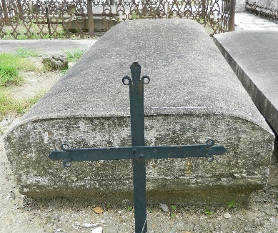

A resident of Amite, LA, died at 6:49 AM on Saturday, October 27, 2012 at his residence near Amite, LA. He was born January 26, 1931 in Lions, LA and was 81 years of age.
Visitation at McKneely Funeral Home, Amite, from 6 p.m. until 9 p.m. on Tuesday and from 8 a.m. until 9:30 a.m. on Wednesday, October 31, 2012.
Mass of Christian Burial St. Helena Catholic Church, Amite, LA at 10 a.m. Wednesday. Interment St. Peter Catholic Church Cemetery, Reserve, LA.
Survived by wife, Beverly Raffray Oubre, Amite, LA, daughter, Linda O. Drago and her husband, Victor, Houston, TX, 3 step-daughters, Jackie Hebert and her husband, Donnie, Madelyn Stein, Tassy Donaldson and her husband, Taft, 2 sisters, Iris O. Develle, Metairie, LA Cynthia O. Vicknair, Reserve, LA, 3 grandchildren, Dana and Sergio Mendez, Nicholas Drago, Noelle Drago, 2 great-grandchildren, Dillon and Giada.
Preceded in death by parents, Oliver Oubre, Jr. And Edwina Englade Oubre, sister, Eula Boudreaux, 3 brothers, Allen J. Oubre, Alvie E. Oubre, Richard P. Oubre.

McKneely Funeral Home, Tangipahoa Parish, Louisiana

