Ronnie J. Oubre
February 23, 1952 – September 13, 2011

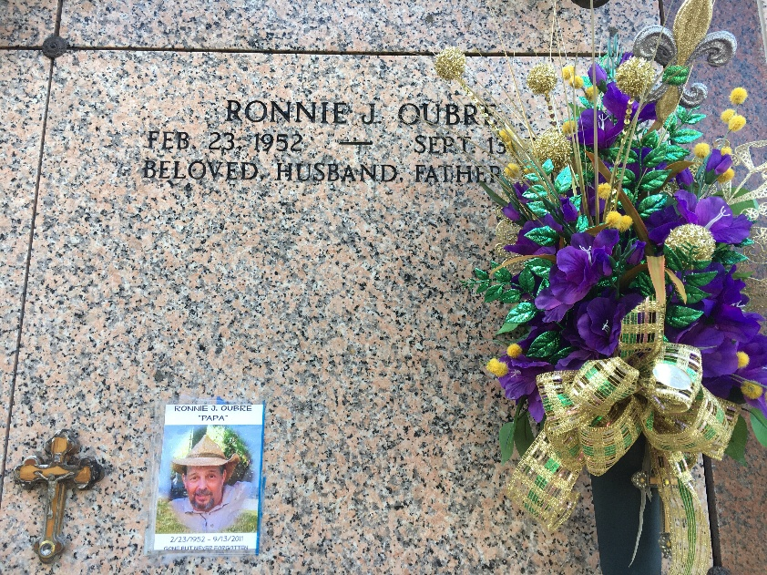
Photo by Team T-Lo

Ronnie J. Oubre passed away on Tuesday, September 13, 2011.
Beloved husband of Donna Wright Oubre. Father of Nicole O. Landry (Grant) and Misty O. Moore (Wayne). Grandfather of Kailee, Hunter and Braiden Landry and Rhett and Rylee Moore. Son of Eliza Zeringue Oubre and the late Maurice Oubre Sr. Brother of Shannon Bier and Maurice Oubre Jr. (Peggy). Age 59. A native of Reserve and a resident of LaPlace, LA.
Relatives and friends are invited to attend services. Visitation at Millet-Guidry Funeral Home, 2806 W. Airline Hwy., LaPlace, LA, on Thursday, September 15, 2011 from 5:00 pm to 9:00 pm and on Friday from 9:00 am to 11:30 am., followed by Religious Services in the Funeral Home Chapel at 11:30 am. Burial in St. Peter Cemetery Reserve, LA.

The Times-Picayune, New Orleans, Louisiana
September 15, 2011

