Carolyn Theresa (Millet) Ourso
June 20, 1934 – June 23, 2019

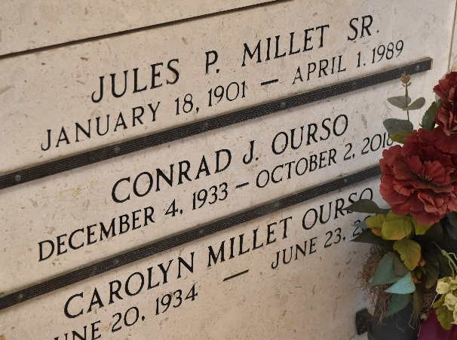

Carolyn Theresa Millet Ourso passed away on Sunday June 23, 2019 at the age of 85.
Carolyn was the beloved wife of the late Conrad J. Ourso. Loving mother of Carey Ourso, wife Suzette and Craig Ourso, wife Missie Monica. Mother-in-law of the late Cindy Ourso. Grandmother of Kristen Ourso, Austin Ourso, Nick Ourso, Adrienne Ourso, Lance Ourso and the late Andrew Craig Ourso. Daughter of the late Jules P. Millet Sr. and Holston Moseley Millet; sister of H. David Millet, the late Betty Lou Guidry and late Jules (Sonny Boy) Millet Jr.
A native of Reserve, LA, former resident of Gramercy, LA and a resident of Prairieville, LA. She was a devote Catholic. She always spoke about her fine memories as a young adult while employed as the secretary at St. Peter School.
Relatives and friends are invited to attend services at Rose Lynn Funeral Home, 1870 Cabanose Ave, Lutcher, LA on Tuesday June 25 from 6:00 pm to 9:00 pm and on Wednesday at St. Peter Church, 1550 LA-4A, Reserve, LA from 10:00 am to 12:00pm. A Mass of Christian burial will be celebrated at 12 Noon and burial will follow in St Peter Cemetery, Reserve, LA.

Rose Lynn Funeral Home, Lutcher, Louisiana

