Conrad Joseph Ourso
December 4, 1933 - October 2, 2018

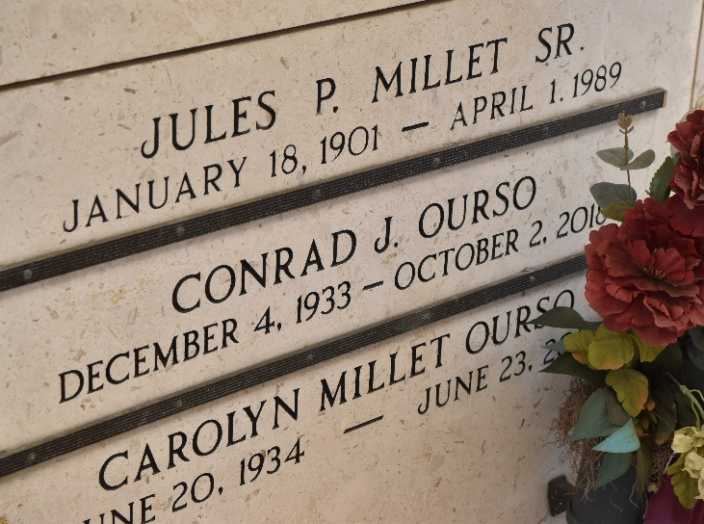

Conrad J. Ourso passed away on Tuesday, October 2, 2018 at the age of 84. Beloved husband of Carolyn Millet Ourso. Father of Carey, fiancé Suzette Slocum, and Craig, wife Missie Monica. Father-in-law of the late Cindy Ourso. Grandfather of Kristen Ourso, Austin Ourso, Nick Ourso, Adrienne Ourso, and Lance Ourso. Preceded in death by his mother, Julia Martinez Ourso; father, Morris Ourso; stepmother, Lydia Ourso; and brothers, Dudley Ourso and Jerry Ourso.
A native of Gramercy, LA and former resident of Westwego, LA. He was the Plant Manager of Colonial Sugars and a veteran of the US Army. He was an avid fisherman, devoted husband, and loving father and grandfather.
Relatives and friends are invited to attend services. Visitation at Rose Lynn Funeral Home located at 1870 Cabanose Avenue in Lutcher, LA on Friday, October 5, 2018 from 6 pm to 9 pm. Visitation at St. Hubert Catholic Church in Garyville, LA on Saturday, October 6, 2018 from 9 am to 11 am followed by a Mass of Christian Burial. Burial at St. Peter’s Cemetery in Reserve, LA.

Rose Lynn Funeral Home, Lutcher, Louisiana

