Ora (Key) Palermo

October 19, 1914 – November 14, 2002

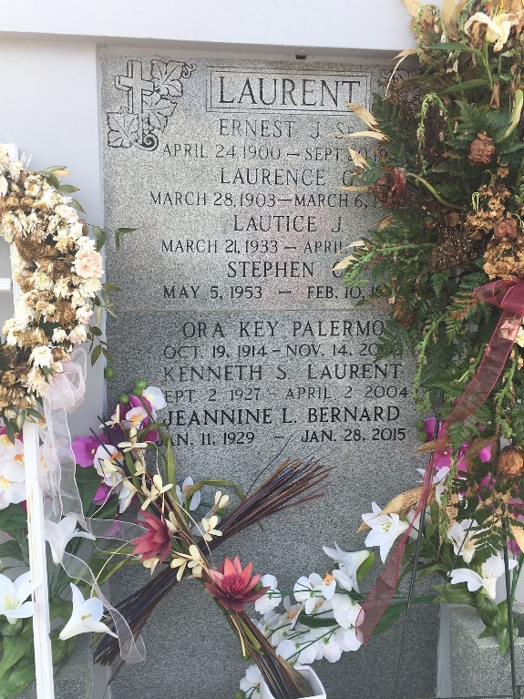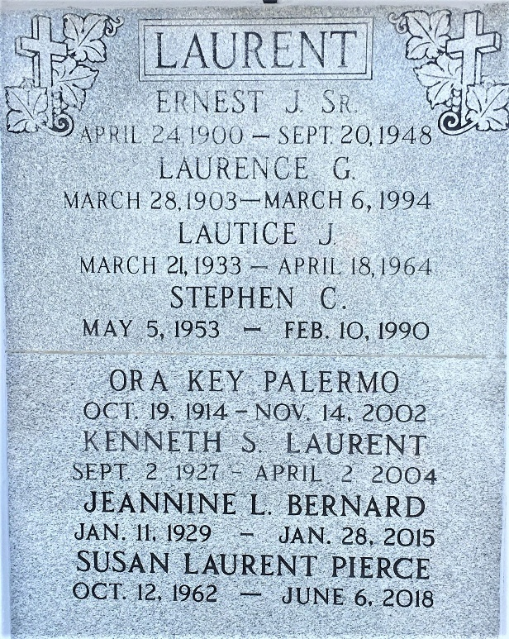

Photos by Team T-Lo

Ora Key Palermo, In Bush, Louisiana, On Thursday, November 14, 2002 At 3:30 P.M.  
 Beloved Mother Of Linda Faulstich Of Dallas, Texas, Michael (Mac) Mcguire And The Late Lautice Laurent. Sister Of Jewell Stringer, Mary Ford And The Late Effie Shukis. Also Survived By 8 Grandchildren And 8 Great Grandchildren.  
 Servent To Her Lord, Family And Friends. Relatives And Friends Of The Family Are Invited To Attend The Funeral Service From The Jefferson Chapel Of Tharp Sontheimer Tharp Funeral Home, 1600 N. Causeway Blvd. At 43rd Street, Metairie, La On Monday, November 18, 2002 At 11:00 O'clock A.M. Interment In St. Peter Cemetery In Reserve, La. Visitation On Monday, November 18, 2002 From 9:00 O'clock A.M. Until 11:00 O'clock A.M.

Times Picayune, New Orleans, Louisiana

November 11-17, 2002  
  
Marriage #1 - 12 Jan 1932 • Jackson County, Florida to C. E. Jones  
Marriage #2 - Richard Gilroy Whiddon (1910 GA–1949 FLO) # 117462674  
Marriage #3 - Raymond Alton "Mac" Sr. McGuire (1907 LA–1951 LA)  
Marriage #4 - ? Palermo