Lucille (Jones) Parker
November 27, 1926 – September 28, 2018

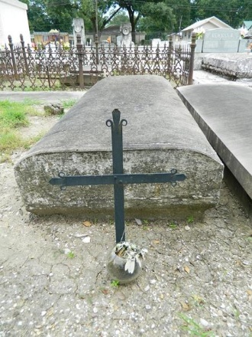

Lucille Jones Parker, a native of Chicago, IL and a resident of New Orleans, LA entered eternal rest at the age of 91 on Friday, September 28, 2018 at the Covenant Nursing Home.
Lucille was preceded in death by her husband Alphonse Parker, her parents George and Pauline Jones, brother, Theodore Jones Sr. (Pauline) sister in law.
She attended St. Monica Catholic School and continued her education at St. Mary’s Academy High School, where she dominated her skills on the basketball court. She was a life -long resident of New Orleans. She was a retired domestic worker.
Lucille was a faithful parishioner of Holy Ghost Catholic Church now St. Katharine Drexel Catholic Church. She was a member of the Holy Ghost Usher Society, one of the original members of Holy Ghost Senior Choir, St. Katharine Drexel Gospel Choir and a member of the Sodality. She was a member of the Knights of Peter Claver Ladies of Grace M.L. Lunnon Grand Chapter 4 and Knights of Peter Claver Ladies Auxiliary St. Theresa Little Flower Court 52.
Cherishing her memories are her two sons: Calvin Parker Sr. (Carolyn Cinnamon Reeves) and Roland Jones of Monroe, LA, grandchildren: Calvin Parker Jr. (Krystal) of Lafayette, LA, Chanelle Parker-Robinson (Ivan Jr.) and Amanda Darensbourg. 11 great grandchildren: Aaron Jr., Kayla, Ahmad, Calbey, Ivan III, Calvin III, Avant, Ionesti, Ian and Idris, goddaughter: Karen Thomas McWilliams (Darrin), niece: Karen Jones Roberts, nephews: Theodore Jones Jr. and Eugene Jones of Atlanta, GA. She also survived by a host of nieces, nephews, cousins and friends.
Relatives and friends of the family, also Priest and Parishioners of St. Katharine Drexel C.C. are invited to attend the Mass of Christian Burial at 10:00 AM on Saturday, October 6, 2018 at St. Katharine Drexel C.C., 2015 Louisiana Ave. New Orleans, LA 70115. Visitation will be from 8:00 AM until 10:00 AM.

Rhodes Funeral Home, New Orleans, Louisiana

