Charles Joseph Parquet
October 8, 1896 – May 2, 1979

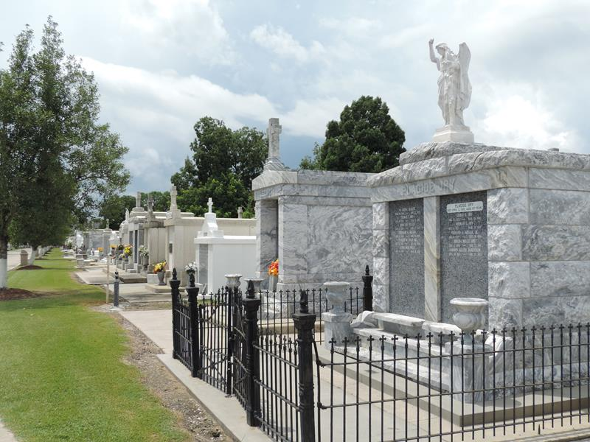

Charles (Charlie) Joseph Parquet, of LaPlace, La., at the V. A. Hospital, in New Orleans, La., on Wednesday May 2, 1979, at 3 o'clock a.m. husband of Olevia Parquet, father of Thomas, Stanley, Eulis, Leonard, Randell and Clyde Parquet of LaPlace, La., Melvin Parquet of New Castle, Delaware, Catherine Deterville, Shirley Doley, Edith Parquet Crawford, and Claire Sherrod of New Orleans, Leah Bazile of Detroit, Mich., and the late Nicholes Parquet; son of the late Mary and Turner Parquet, son-in-law of Marie Robinson, and the late Ike Robinson, Father-in-law of Mary, Leona, Ollie, Martha, Emily, and Mary Ann Parquet of LaPlace, Burnette Parquet of New Castle, Delaware, Stanley Deterville, Edward Doley, and Merlin Crawford of New Orleans, Ronald Bazile of Detroit, Mich., brother-in-law of Hilda Gaines, and Mr. and Mrs. Earl Robinson; also survived by 39 grandchildren, 12 great-grandchildren, a host of nieces, nephews, other relatives and friends, age 81 years.
Relatives and friends of the family, also parishioners of Our Lady of Grace Catholic Church of Reserve, La., officers and members of Sacred Heart Benevolent Association, and Ladies Auxiliary Court No. 73, K.P.C., employees of Pullman Kellog, Dupont Gena Nelson, Bob Brothers, and Floor Company, are invited to attend the funeral. Services from Robottom Mortuary, Reserve, on Saturday May 5, 1979 at 10:15 o'clock a.m., followed by funeral Mass at Our Lady of Grace Catholic Church at 10:30 o'clock a.m. Father M. Stelm, celebrant.
Interment in St. Peter Cemetery, Reserve, La. Wake services at Robottom Mortuary Friday May 4, 1979. Visitation at the mortuary after 5 o'clock p.m. Recitation of the Rosary at 8 o'clock p.m.

The Times-Picayune, New Orleans, Louisiana
May 4, 1979

