Mary Ann (Anderson) Parquet

July 25, 1941 – June 20, 2016

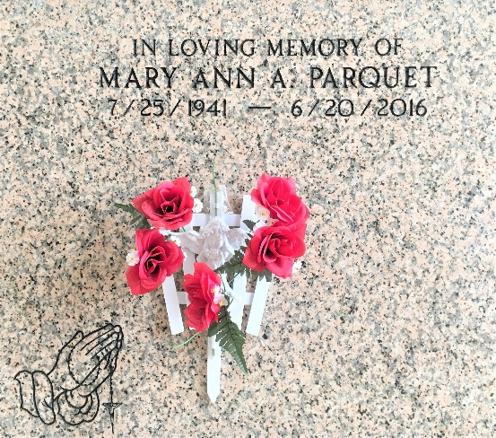

Photo by Team T-Lo

Mary Ann Parquet passed away peacefully on Monday, June 20, 2016, at her home in LaPlace surrounded by her family.

She was the daughter of the late Felice and Freddie Anderson and the wife of Clyde Parquet. She was the mother of Hoyt Parquet Sr., Sylvia Parquet, Clyve Smith, Helena Schnyder and sons-in-law Tony Smith and Aubrey Schnyder Sr. She is survived by ten grandchildren, Teesha Parquet, Aubrey Schnyder Jr., DeVenney Smith, Duanne Leavey, Jirel Leavey, Kimberly Smith, Andre Schnyder, Arnandez Schnyder, A-vonte Schnyder and Hoyt Parquet Jr.; four great grandchildren; four sisters and four brothers.

Relatives and friends of the family, also priest and parishioners of Our Lady of Grace Catholic Church and all neighboring churches are invited to attend the Funeral Mass at Our Lady of Grace Catholic Church, 772 Highway 44 in Reserve on Thursday, June 23 at 10 a.m. Fr. Christopher Amadi is the Celebrant. Interment is St. Peter Cemetery in Reserve. Visitation at the above named church is from 9 a.m. until Mass time. SERVICED BY ROBOTTOM

L’Observateur, LaPlace, Louisiana

June 21, 2016