Olevia (Robertson) Parquet
February 15, 1903 - September 13, 1983

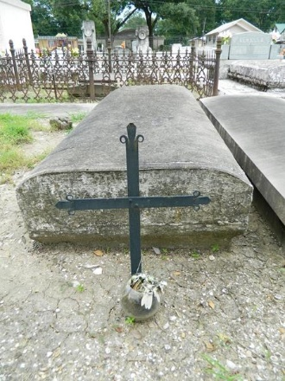

PARQUET

Mrs. Olevia Parquet, of LaPlace, LA, on Tuesday, September 13, 1983, wife of the late Charles Joseph Parquet; mother of Thomas, Stanley, Ernest, Leonard, Randell and Clyde Parquet, of LaPlace, LA, Melvin Parquet of New Castle, DE, Catherine Denterville, Shirley Doley, Claire Sherrod, and Edith Parquet, of New Orleans, LA, Leah Bazile of Detroit, MI, and the late Nicholas Parquet; daughter of the late Maria and Ike Robertson; sister of Earl Robertson, the late Hilda Gaines and Herbert Robertson; sister-in-law of Evelina Robertson and the late Joe Gaines; mother-in-law of Mary, Olevia, Martha, Leona, Mary Ann, and Emily, of LaPlace, LA, Bernette Parquet, of New Castle, DE, Edward Doley, of New Orleans, LA, Ronald Bazile, Sr., of Detroit, MI, and the late Stanley, Sr.; also survived by 46 grandchildren, 28 great-grandchildren, a host of nieces and nephews.
Relatives and friends of the family, also parishioners of our Lady of Grace Catholic Church, of Reserve, LA, officers and members of Ladies Auxiliary Court No. 73, Knights of Peter Claver, employees of Tenneco, St. Mary’s Dominican College, Waterford No. 3, Dr. W Williams, Boh Brothers, Favrot, Charity Hospital, Dupont, City of Delaware, and Nelson Educational Center, of Detroit, MI, are invited to attend the funeral. Services from Robottom Mortuary, Reserve, LA, on Monday, September 19, 1983 at 9:40 a.m. followed by Mass of the Resurrection at Our Lady of Grace Catholic Church at 10:00 a.m. Interment in St. Peter Cemetery, Reserve, LA. Wake services at Robottom Mortuary on Sunday, September 18, 1983. Visitation at the Mortuary after 5:00 p.m. Recitation of the Rosary at 7:00 p.m.

The Times-Picayune, New Orleans, Louisiana
Sunday, September 18, 1983, p. 20

