Randell Parquet, Sr.
July 3, 1935 – February 3, 1984

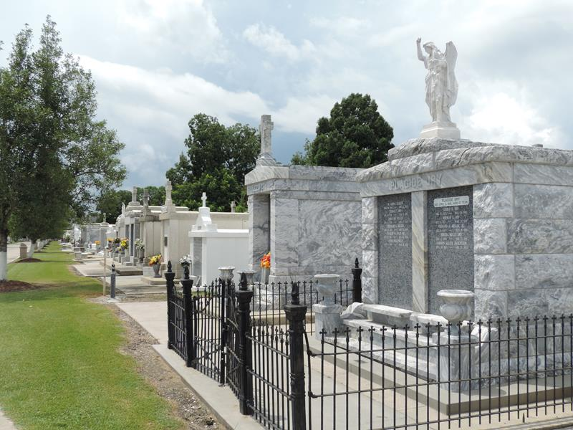

Randell (Skeet-Randy) Parquet, Sr., of LaPlace, La., on Friday, February 3, 1984. Son of the late Charles and Olivia Parquet. Father of E4 Randell, Jr., of Santa Barbara, Seaman Kip Joseph, St. Berendino, Kimberly and Valarie Parquet of LaPlace. Estranged husband of Emily Lewis Parquet. Grandfather of Keyon Parquet of LaPlace. Father-in-law of Cheryle Parquet of Santa Barbara. A devoted friend of Doris Garrison of Kenner, La. Brother of Thomas, Stanley, Eulis, Leonard and Clyde Parquet of LaPlace, Melvin Parquet of New Castle, Delaware, Catherine Deterville, Shirley Doley, Edith Parquet and Claire Sherrod of New Orleans, Leah Bazile of Detroit, Michigan. Nephew of Earl and Evalina Robertson of Hahnville, La. Mary Anne and Martha Parquet of LaPlace, Burnette Parquet of New Castle, Delaware, Edward Doley of New Orleans, Ronald Basile of Detroit Michigan and the late Stanley Deterville, also survived by a host of nieces, nephews, other relatives and friends. Age 48 years.
Relatives and friends of the family, also Parishioners of Our Lady of Grace Catholic Church of Reserve, La. and St. Joan of Arc Catholic Church of LaPlace and employees of Favrot Construction Company are invited to attend the funeral. Services from Robottom Mortuary, Reserve, La., Wednesday, February 8, 1984 at 9:20 a.m. followed by Mass of the Resurrection at John of Arc Catholic Church, LaPlace at 10 a.m. Interment in St. Peters Cemetery, Reserve. Wake Services at Robottom Mortuary, Tuesday, February 7, 1984. Visitation at the Mortuary after 5 p.m. Recitation of the Rosary, at 8 p.m. Serviced by Rubottom.

The Times-Picayune, New Orleans, Louisiana
1984

