Marlon C. Pellissier

October 21, 1942 – May 6, 2006

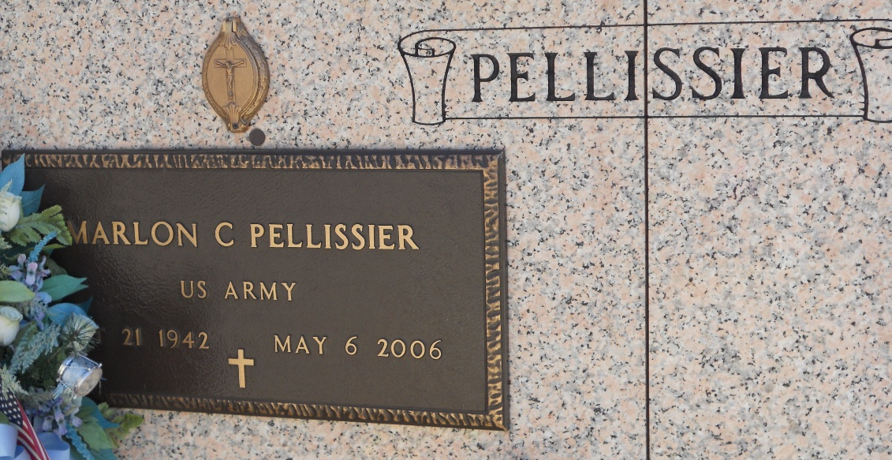

Photo by Team T-Lo

Curtis T. Pellissier on Wednesday, August 5, 1970, at 3:30 o'clock a.m.,

Beloved husband of Louise Millet, father of Marlon Pellissier, Mrs. Gaynel Roussel and Mrs. Sharon Catham of Garyville, Louisiana, son of Heiene Pellissier of New Orleans, Louisiana and the late Joseph C. Pellissier, brother of Mrs. Claire Ryais of Metairie, Louisiana and Mr. Grant Pellissier of New Orleans. Also survived by 5 grandchildren,

Age 50 years, a native of New Orleans and a resident of Garyville, Louisiana for the past 28 years.

Relatives and friends of the family, also Employees of Kaiser Aluminum & Chemical corporation of Gramercy, Louisiana and members of the VFW and Ladies Auxiliary of Post 8167, Garyville, Louisiana and also members of the VFW and Ladies Auxiliary of the Department of Louisiana, are invited to attend the funeral.

Services from Millet funeral home, Reserve, Louisiana on Friday, August 7, 1970 at 10 o'clock a.m. Religious services at St. Hubert Catholic Church, Garyville, Louisiana at 10:30 o'clock a.m. Interment St. Peter's Cemetery, Reserve, LA. Friends may visit after 3:30 p.m. on Tuesday.

Fondly missed by Sharon, Gaynel, Marlon and Grandchildren.

Unknown newspaper clipping