Troy Anthony Peranio
July 11, 1963 – February 9, 2023

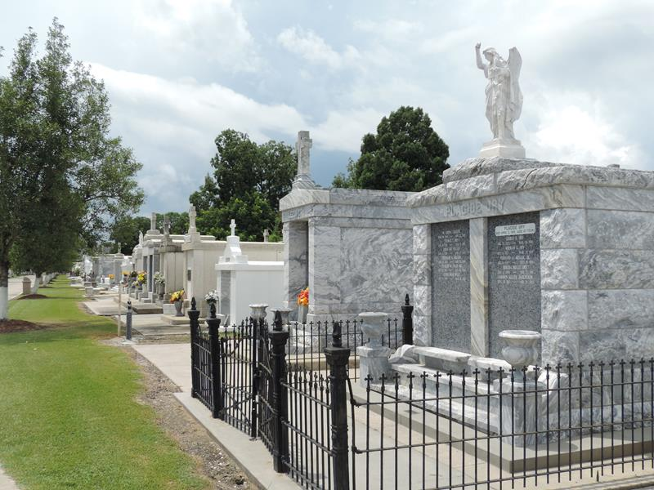

Troy Peranio a native of Reserve and a resident of LaPlace, passed away on Thursday, February 9, 2023 at the age of 59.
Beloved son of the late Firmin Peranio and Cynthia Peranio. Brother of Melissa Trafficano (Michael), Maria Garrett (Michael) , Rebecca Ross, and Rachel Guillory. He is also survived by numerous nieces and nephews.
Family was the most important thing to Troy. His greatest hope was that everyone in the family loved each other equally. Troy also had a big passion for music, especially the bands The Scorpions and Black Sabbath.
Relatives and friends are invited to attend the Visitation and Memorial Mass at Millet-Guidry, 2806 West Airline Hwy, LaPlace on Thursday, February 16, 2023. Visitation will be held from 9:00 a.m. to 11:00 a.m. with the Memorial Mass to immediately follow at 11:00 a.m. Interment will be held in St. Peter Cemetery.

Millet-Guidry Funeral Home, LaPlace, Louisiana
Feb. 13, 2023

