Vince C. Peranio

1910 – April 12, 1958

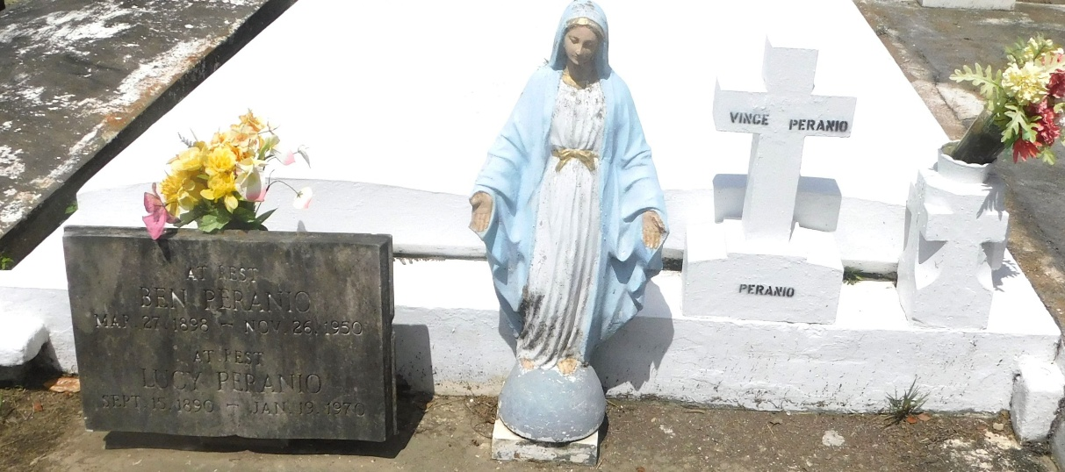

Photo by Mary Agnes Hammett

Peranio - At Veterans hospital, New Orleans, La., on Saturday, April 12, 1958, at 7:30 o'clock a.m., Vince C. Peranio, husband of Octavie Bourgeois; son of Lucy Palermo and the late Bernardo Peranio; brother of Roy Peranio and Mrs. Mary Theriot of Bridge City, La., Sam Peranio of Montz, La., Mrs. Josie Mier and Mrs. Jennie Fox of New Orleans, La., and the late Dominick and Luke Peranio; aged 47 years.

Relatives and friends of the family are respectfully invited to attend the funeral, which will take place from the Millet funeral Home, Reser, La., on Monday, April 14, 1958, at 9:30 o'clock a.m., followed by religious services at St. Peter's church, Reser, La. Interment in St. Peter's cemetery.

Unknown newspaper clipping