Willis "Willie" Bernard Peranio

November 9, 1951 - July 21, 2023

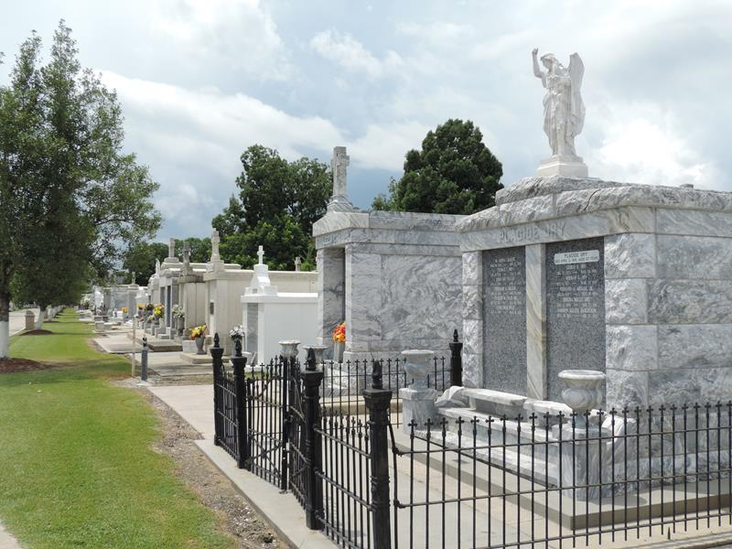

Willis Bernard Peranio, a resident of St. John Parish, passed away peacefully in his home in Reserve on Friday, July 21, 2023, at the age of 71.
He was born on November 9, 1951 in Montz, Louisiana to the late Cecile Hilda Vicknair and the late Sam Peranio. He was the beloved husband of Cheryl Keller Peranio for 28 years and is survived by his children: Lisa Peranio-Schmitt (Richie), Angie Peranio-Raffield (Star), Laurie Peranio-Vice (Sheldon), Jesse Peranio and Justin Peranio (Lance), along with his grandchildren: Ashlynn and Aidan Hodges, Cody and Cole Comeaux, Trey Vice, Star and Ridge Raffield and Rayne Peranio, along with his great-granddaughter, Anthem Musso. He is also survived by his brothers Sam Peranio, Jr. (Stephanie) and Michael Peranio. He was preceded in death by his brother Firmin Peranio and sister Janice Brady.
He was a veteran of the Air Force Reserves and a dedicated employee of Nalco Chemical Company, which he retired from after 31 ½ years. Willie played baseball in his youth and loved sports, especially Tulane and the Saints, fishing and having a good time with his family and friends.
Relatives and friends are invited to attend a Funeral Mass at 11:00 AM on Saturday, July 29, 2023 at St. Peter Catholic Church, 1550 Hwy 44, Reserve, LA 70084. Visitation will begin at 9:30 AM.

Millet-Guidry Funeral Home, LaPlace, Louisiana

