Agnes Rose (Verret) Perilloux
July 16, 1883 – January 19, 1975
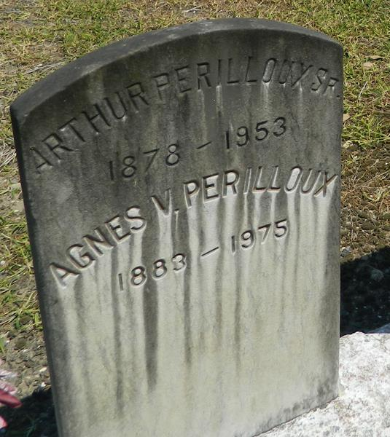

Agnes Verret Perilloux died Sunday, 19 Jan 1975, at age 91 years. She was the wife of the late Arthur J Perilloux and mother of Jules E, Arthur J Jr, Mrs. E S Weaver of New Orleans, Leroy F of Kenner, Burton of St Rose, and Stanley J of Denver, Colorado, Mrs. Lolan Badeaux of Destrehan, Mrs. Arthur Lewis and Mrs. Alfred Bourg of Good Hope. She was the sister of Mrs. Eunice Triche of Garyville, Mrs. Alice Boutte of New Orleans, Mrs. Rose Blanchard of Franklin and Oscar Verrett of Folsom. Also survived by 16 grandchildren, 52 great grandchildren and 10 great great grandchildren. She was a lifelong resident of Laplace.
Funeral services were from Millet Funeral Home on Tuesday 21 Jan 1975 followed by religious services at St Joan of Arc Catholic Church, Laplace. Interment in St Peter Cemetery, Reserve, La.
Unknown source

