Albertine Marie (Simoneaux) Perilloux

December 6, 1901 – August 19, 1990

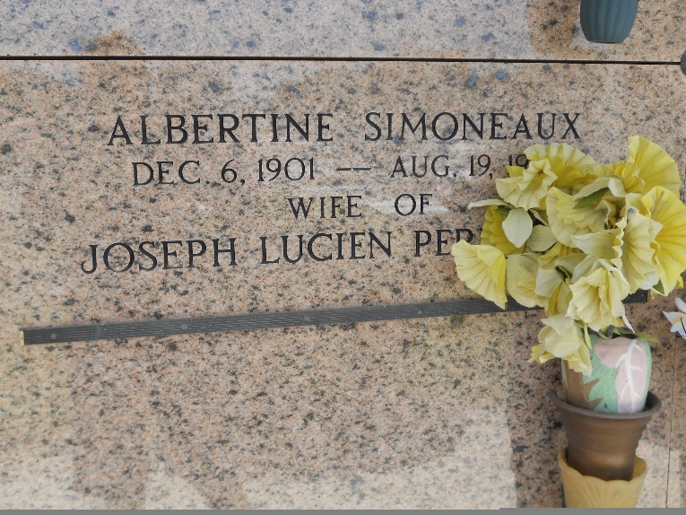

Photo by Team T-Lo

Albertine M. Perilloux died Sunday 19 Aug 1990 at 2:29 a.m. at age 88 years. She was a native of Montz, Louisiana, and a resident of Laplace, Louisiana. She was the wife of the late Lucien Perilloux and the mother of Anna Mae Schutz, Calvin, Raymond, Leonard, Ronald, Dolores Millet and Brent Perilloux. Also survived by 26 grandchildren and 30 great-grandchildren. She was the sister of Edgar, Felix Jr, Melvin and Murphy Simoneaux, Heloise Tassin, Sedonia Labat and the late Clarence and Frank Alberit Simoneaux.

Services were Monday, 20 Aug. 1990 at St Joan of Arc Catholic Church, Laplace, with interment in St Peter Cemetery, Reserve, Louisiana.

The Times-Picayune, New Orleans, Louisiana

20 Aug 1990