Andre Toussaint Perilloux
November 1, 1864 – February 7, 1940

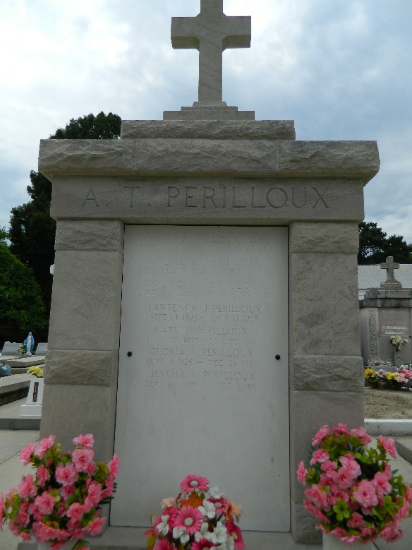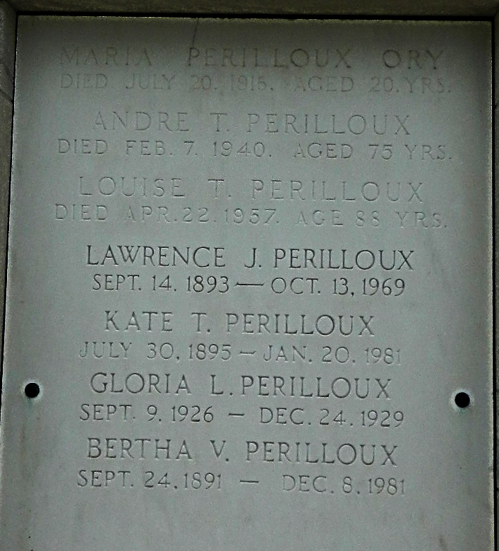

Andre T Perilloux died at Laplace, Louisiana, on Wednesday 7 Feb 1940 at 6:10 p.m. at age 75 years. He was an employee of the Yazoo & Mississippi Valley Railroad for 47 years.
He was the husband of Louise Tregre and the father of Lawrence and Bertha Perilloux of Laplace, Mrs. Emile Hotard of Reserve, Louisiana, and Henry Perilloux of La Lima, Honduras. He was the grandfather of Myrtle and Jerry Perilloux and Jewell and Emile Hotard Jr.
Services were Thursday 8 Feb 1940 at St Peter Church, Reserve, with interment in St Peter Cemetery, Reserve.
The Times-Picayune, New Orleans, Louisiana
8 Feb 1940

