Arthur Joseph Perilloux Jr.
October 8, 1924 – December 27, 1975

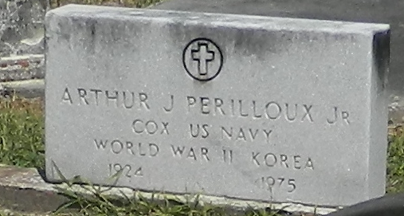

Father of Patrick A. Perilloux and Glenn M. Perilloux. Son of the late Agnes Verret and Arthur J. Perilloux Sr. Brother of Mrs. Joyce Weaver, Mrs. Gladys Badeaux, Mrs. A. H. Lewis, Mrs. Alfred Bourg, Jules E., Burton B., Leroy F. Perilloux and Stanley J. Perilloux of Denver, Colorado.
Interment in St Peter Cemetery, Reserve, Louisiana

The Times-Picayune, New Orleans, Louisiana
29 Dec 1975

