Aurelia (Denoyer) Perilloux
January 3, 1844 – March 7, 1926

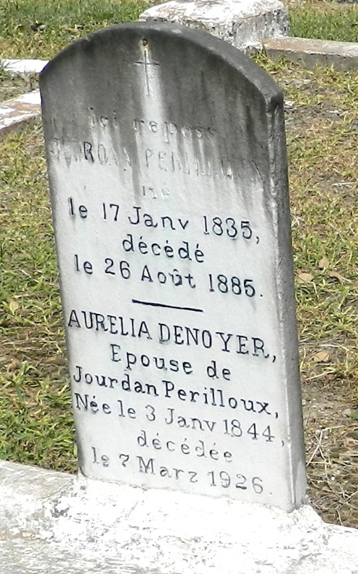

Mrs. Jourdan Perilloux, née Aurelia Denoyer, died at the home of her granddaughter, Mrs. Armand Montz, in Laplace, LA, on Sunday [7 Mar 1926] at 1 am at age 82 years. She was born in Laplace on 3 Jan 1844, lived in Reserve, LA, until 1923 when she moved to Laplace to Mrs. Montz's home after the death of her daughter, Devienne Perilloux. Survivors are Mrs. Andre Triche of St Gabriel, LA, J D Perilloux of Franklin, LA, Mrs. Edmond Becnel of St Gabriel, Mrs. H Bodin of Reserve, Arthur Perilloux of Laplace, 33 grandchildren and 17 great-grandchildren.
L'Observateur, LaPlace, Louisiana
13 Mar 1926

