David Lee Perilloux

September 4, 1954 – September 30, 1974

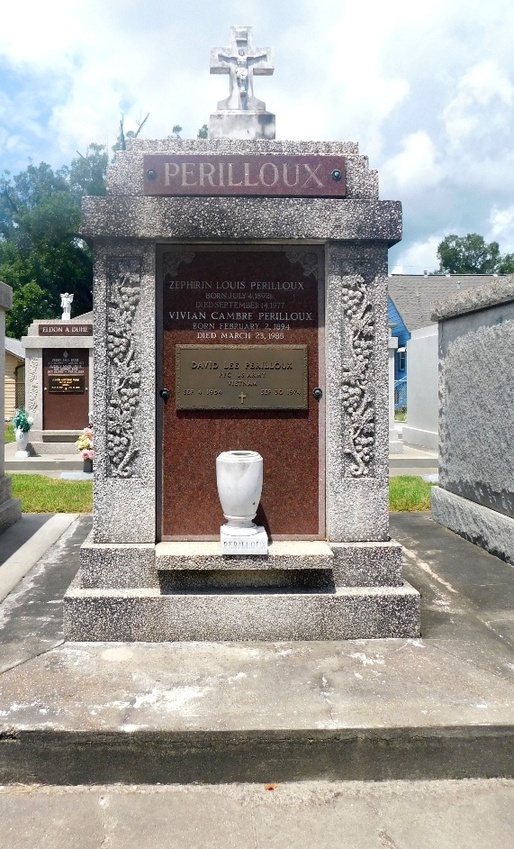 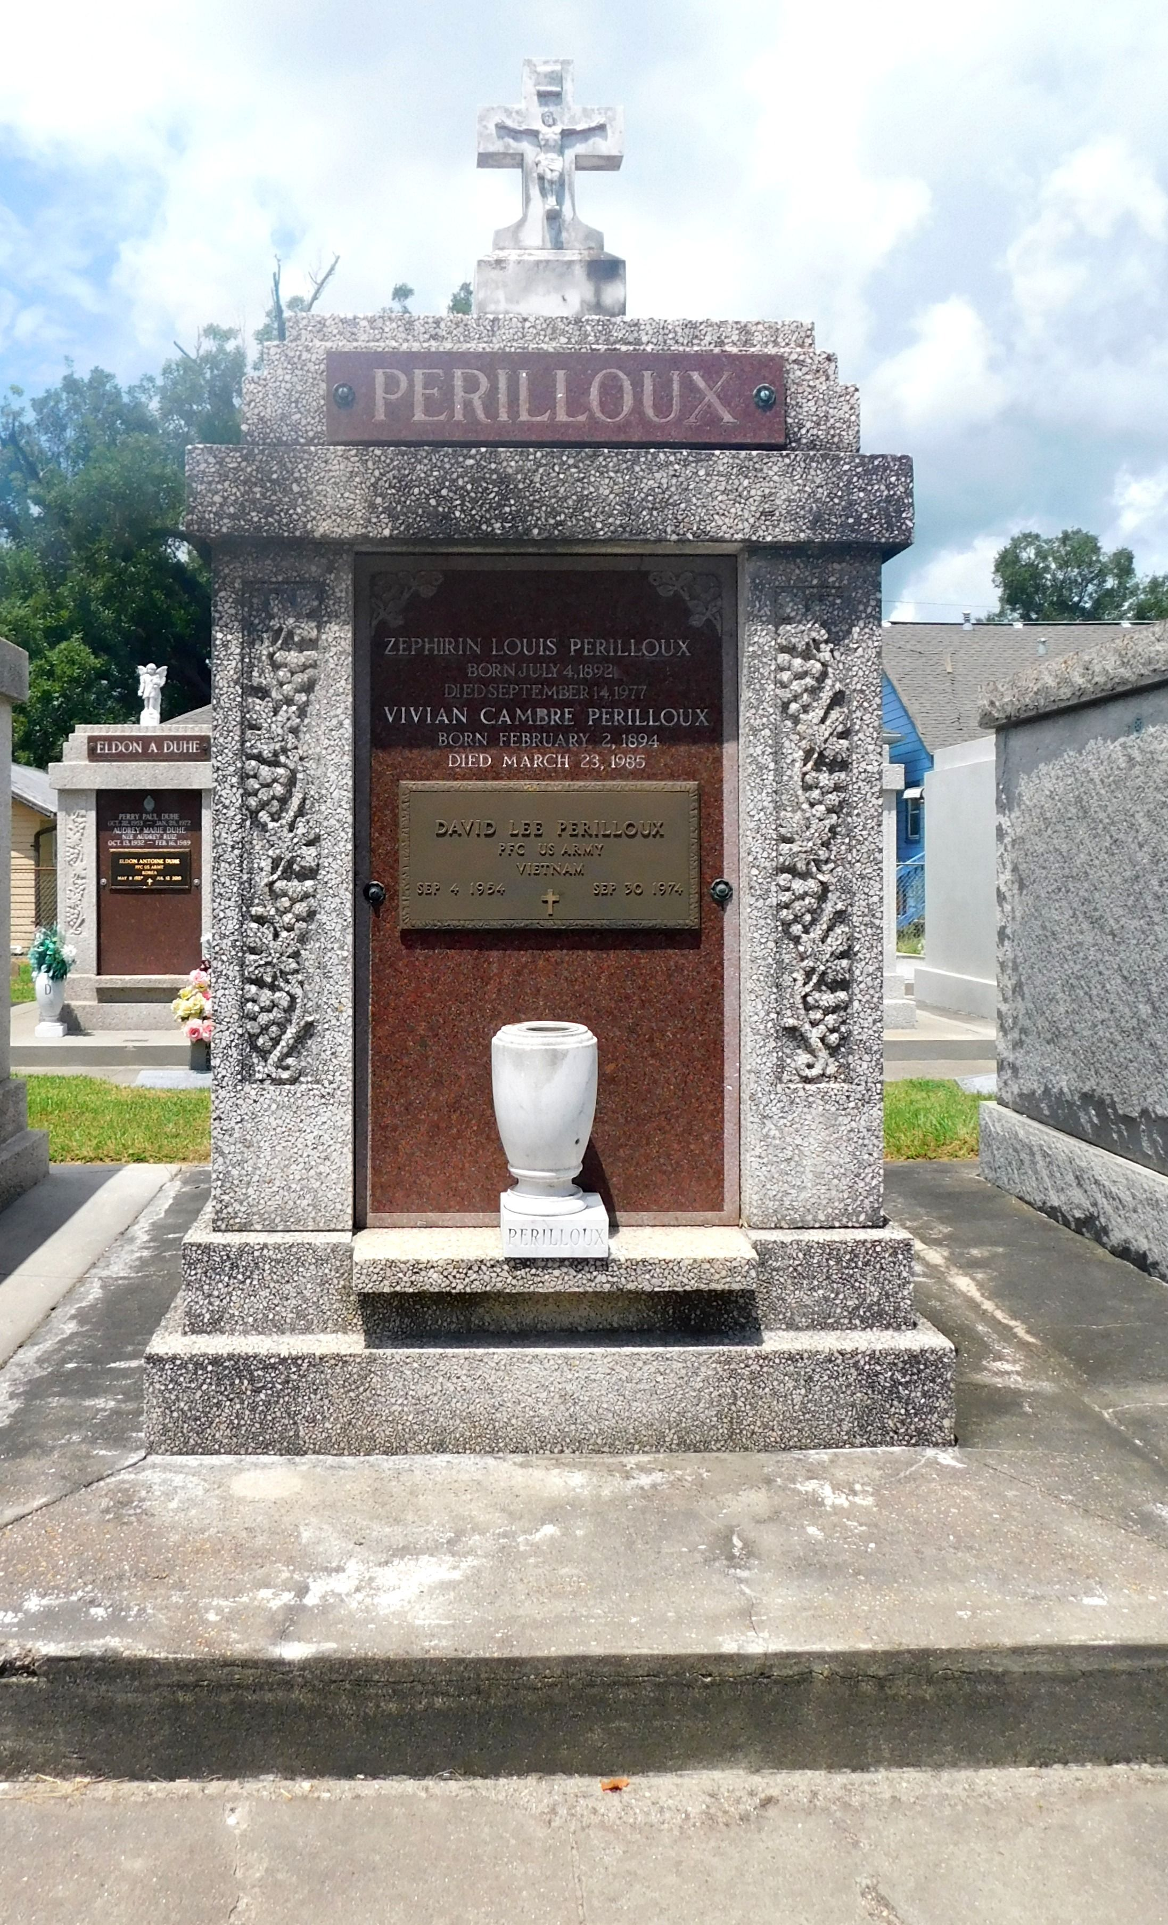

Photos by Mary Agnes Hammett

PFC Perilloux, age 20, died in Milano, Texas, in an automobile accident while returning to his duty station at Ft Hood, Texas.

He was a graduate of Destrehan High School and the son of Emmett Perilloux and Elaine Verret Perilloux. He was the brother of Mrs. Philip (Gayle) Tassin of Norco, Louisiana, Mrs. Kenneth (Gwen) Gaillot of Metairie, Louisiana, Miss Donna Perilloux of New Orleans, Miss Charlene Perilloux of Laplace, Louisiana, and Mrs. Larry (Cherie) Boudreaux of New Orleans.

Services were Friday 4 Oct 1974 at Sacred Heart of Jesus Church, Norco, with interment in St Peter Cemetery, Reserve, Louisiana, with full military honors.

The Times-Picayune, New Orleans, Louisiana

October 3 & 4, 1974