Denise (Millet) Perilloux

April 1, 1899 – January 16, 1973

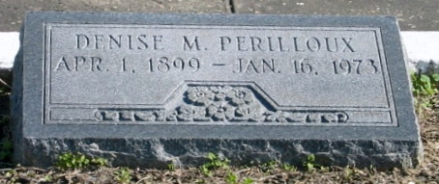

Photos by Bobby

Denise Millet Perilloux, a native and resident of Laplace, Louisiana, died Tuesday, 16 Jan 1973 at 11:15 p.m. at age 73 years.

She was the wife of the late Jourdan D Perilloux Jr and the mother of Mrs. T. J. (Marguerite) Trussell Jr of Michigan, Mrs. George D (Kathleen) Ellstrott of Metairie, Louisiana, Mrs. Harry G. (Yvonne) Aucoin Jr of Laplace, Mrs. Frederick (Evelyn) Hare of New Orleans, Mrs. James M. (Ida) Nobles of Houma, Louisiana, Mrs. John W. (June) Maurin of Teheran, Iran, and J. D. Perilloux III of Vivian, Louisiana. She was the sister of Miss Antoinette Millet, Mrs. Wallace Sicard, Mrs. Andrew Stein and Mrs. John Nobile and Ernest Millet. Also survived by 19 grandchildren.

Services were Thursday, 18 Jan. 1973 at St Joan of Arc Church, Laplace, with interment in St Peter Cemetery, Reserve, Louisiana.

The Times-Picayune, New Orleans, Louisiana

18 Jan 1973