Eva (Rousselle) Perilloux
July 26, 1909 – April 24, 1999
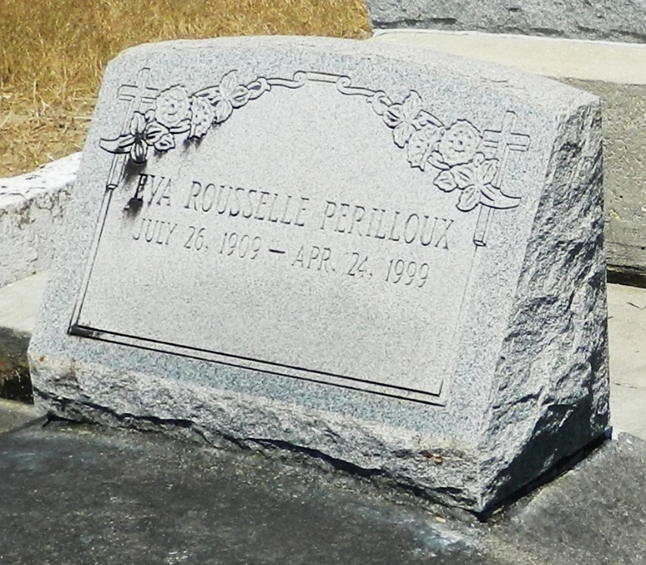

Eva Rousselle Perilloux, 89, a native of Lucy and a resident of LaPlace for 73 years, died April 24.

She was the wife of the late Cleveland Perilloux and mother of Joyce Millet, Cynthia Cambre and Cleveland Jr., Allen and the late G. Wayne Perilloux. She was also the daughter of the late Ignace and Ernestine Rousselle and sister of the late Annette Deslattes, Leonie Madere and Adam, Pheophile, Ben and Leona Rousselle. She is also survived by 14 grandchildren and 28 great-grandchildren.

Services were held April 27 in the chapel of Millet-Guidry Funeral Home, LaPlace, with interment at St. Peter Cemetery, Reserve.
L'Observateur, LaPlace, Louisiana
April 28, 1999

