Felix Perilloux
March 9, 1840 – December 15, 1902

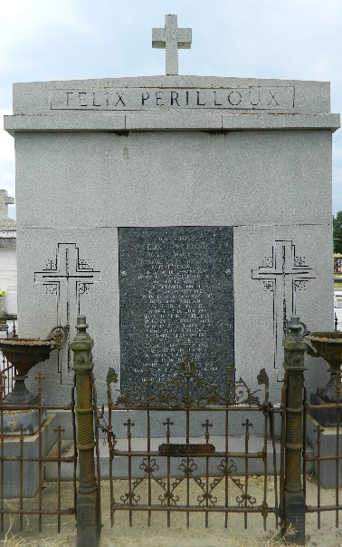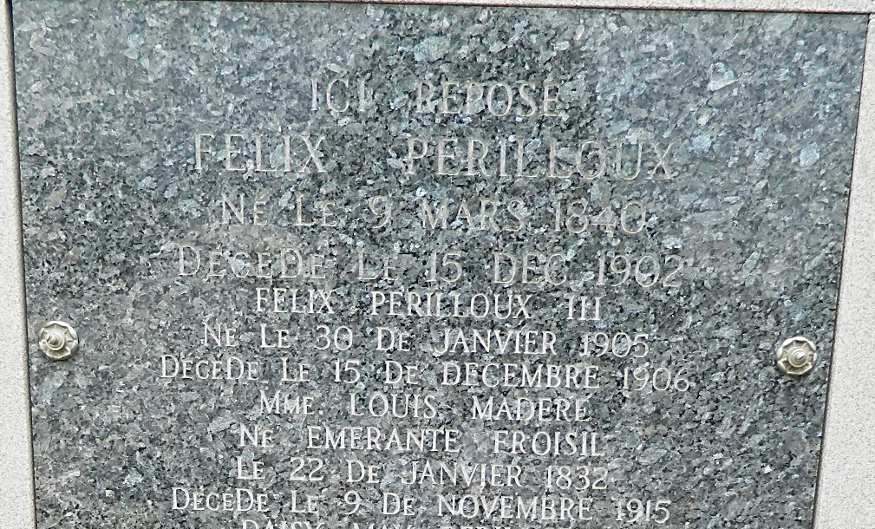

State of Louisiana, Parish of St. Charles
Be it known that on this Eleventh day of December in the year of our Lord one thousand nine hundred and two. Before me, Joseph Clement Triche, Clerk of Court and Ex Officio Notary Public duly commissioned and qualified in and for the Parish of St. Charles, and in the presence of the witnesses hereinafter named and undersigned. Personally came and appeared: Mr. Felix Perilloux, of this Parish who declared that his full name is Felix Perilloux.
That being of lawful age and sound of mind and memory and being desirous in view of uncertainty of life, of making his last will and testament in accordance with the laws of Louisiana regulating testaments by nuncupative acts. Here the said Testator has now declared to me, the undersigned Clerk of Court and Ex officio Notary, in the presence of the said witnesses the following last will and testament, which I, the undersigned Clerk of Court and ex officio Notary, has written as dictated to me by the said testator in the presence of the witnesses, the whole at one time without interruption and without turning aside to other acts.
"I was married twice. I was married first to Mistress Myrtle (sic) Froisy of which marriage the following children are now living namely: Felix Didier Perilloux, Honorine Perilloux, wife of Albert Millet, Marie Perilloux, wife of Olide Cambre, Cecile Perilloux, and Nellie Perilloux. I was married the second time with Mistress Louisa Madere, of which marriage there were the following children, viz: Ida Perilloux, Zepherin Perilloux and Joseph Perilloux.
"I give and bequeath to my wife to my wife Mrs. Louisa Madere Perilloux and my three children Ida, Zepherin and Joseph Perilloux in the following proportion, viz: one half to my wife and one half to be divided among my said children, Ida Zepherin and Joseph Perilloux, all the property situated in this Parish purchased by me from Zepherin Hymel, on the 30th day of July 1898 by act passed before J. C. Triche Clerk of Court of this Parish, together with all the improvements thereon, all mules, horses, cattle, hogs and chickens, carriages, carts and agricultural implements harnesses, and gear that is used for the cultivation of said property also the store and its contents.
I give and bequeath to my children born of my first marriage with Mistress Myrthe Froisy, namely Felix Didier Perilloux, Honorine Perilloux, wife of Albert Millet, Marie Perilloux, wife of Odile Cambre, Cecile Perilloux and Nellie Perilloux in the proportion of one fifth each.
The property situated in this Parish purchased by me from Joseph Laurent, on the 11th day of March, 1898, by act passed before J. C. Triche, Clerk of Court of this Parish together with all the mules, carts and agricultural implements used in its cultivation--also five promissory notes drawn and subscribed by Felix Didier Perilloux and Albert Millet dated Parish of St. John the Baptist in one, two, three, four, and five years after date and paraphed (sic), "Ne Varieteur: by Zenon Millet, Clerk of Court and Notary for the Parish of St. John the Baptist on the 25th day of February 1902, each for the sum of Five hundred Three and 70/100 Dollars also two promissory notes drawn and subscribed by Ursin Duhe and Louis Duhe Jr., dated Parish of St. John the Baptist, in two and three years after date and were paraphed (sic) "Ne Varieteur" by Zenon Millet, Clerk of Court and Notary for the Parish of St. John the Baptist, on the 12th day of January, 1901, each for the sum of One hundred and eighty-three and thirty three and a third hundredths dollars, also all of the empty molasses barrels in the cooper shop situated on the property of F. Didier Perilloux and Albert Millet in the Parish of St. John the Baptist, all the barrel staves and material used in making barrels.
After all my just debts are paid I bequeath the residue of my estate and all that I may die possessed of to my said children namely: Felix Didier, Honorine, Marie, Cecile and Nellie Perilloux in share alike. I appoint my son Felix Didier Perilloux as executor of this my last will and testament, with bond with full seizin of all my estate.
And now, said testator having declared that he had no further declaration to make, I the undersigned Clerk of Court and Ex officio Notary, have read over in full this last will and testament to the said testator in presence of the three undersigned witnesses, residents of his Parish and in the place where this will is executed, all at one time without interruption and without reverting and turning aside to other acts.
In faith whereof, I have closed the present act of last will and testament, in presence of said testator and of Messieurs Adam Perilloux, Achille Montz, and Olide Cambre, witnesses of lawful age, residing in this Parish and the said testator and witnesses have signed these presents with me, said Clerk of Court and Ex officio Notary, the Month and Year first above written.

<Signed>
Felix Perilloux
Adam Perilloux, Achille Montz, Olide Cambre, J. C. Triche

