George W. Perilloux
October 12, 1881 – October 6, 1958
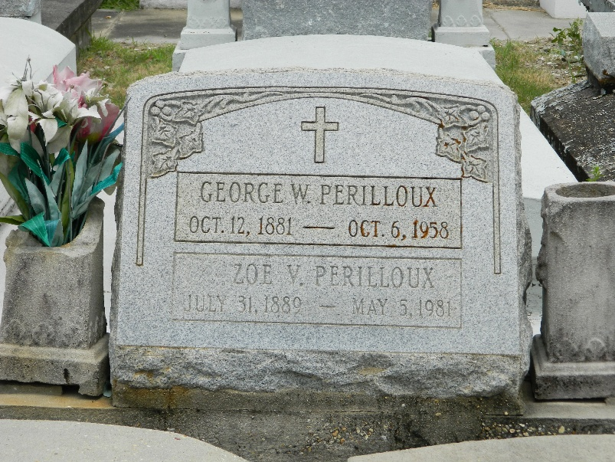

George W. Perilloux died in Reserve, Louisiana, on Monday 6 Oct 1958 at 1:30 pm at age 77 years.

He was the husband of Zoe Vicknair and father of Mrs. Louis Crosby of Metairie, Louisiana, and Mrs. Melville DeNeva of New Orleans.

Services were Wednesday 8 Oct 1958 at St Peter Church, Reserve, with interment in St Peter Cemetery, Reserve.
The Times-Picayune, New Orleans, Louisiana
8 Oct 1958

